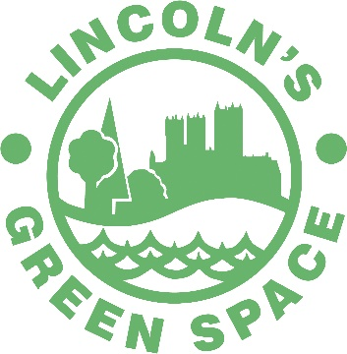

Organising Events in Lincoln’s Green Spaces

The Green Spaces are ideal places to hold your own event, from community picnics to concerts and festivals. We welcome requests from groups, businesses, and organisations to organise their own events and activities within the Green Spaces of Lincoln.
This guide has been written for people who would like to hold safe and successful small and larger events.

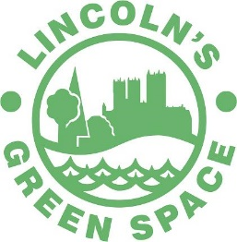
Notes For Event Organisers
An Event Application Form must be completed for all events held within Lincoln’s Green Spaces. Checklists are provided on the application forms and should be filled out according to the size of the event. The Green Spaces which can be used with in the City are the following.
- Hartsholme Country Park
- Boultham Park
- Lincoln Arboretum (Suitable for smaller events)
- South Common
- West Common
Completion of the application form DOES NOT confirm permission for the event to take place.
Health and Safety
It is the responsibility of the organisers of an event to ensure that adequate arrangements are made to protect the safety of participants, spectators, and all others likely to be in the vicinity.
You must have Public Liability Insurance and carry out a Risk Assessment. If you need help completing a Risk Assessment, contact the Park Rangers. A template is available.
Safety Plan
For those holding large events a detailed Safety Plan should be included along with the application. A template can be found using the following link, Safety Advisory Group Constitution - Lincolnshire Resilience Forum. A copy of your Safety Plan will be required by the City of Lincoln Council, and the Safety Advisory Group (SAG). We therefore need multiple copies of all your documentation, as stated in the checklists.

Fees
If you are a business which intends to make an income from the event, we suggest a 20% donation of your total takings be given to the Hartsholme Country Park Advisory Group as a gesture of good will.
First Aid
An agreed level of first aid, paramedic and medical facilities should be provided at the organisers expense.
Accidents
The event organisers should advise the Ranger on duty before the end of the event of any accident to a participant, spectator or third party.
Evacuation
In all cases where a crowd is placed in a confined space, either indoors or outdoors, an evacuation procedure should be part of the Risk Assessment appraisal and plan.
Fire Arrangements
Consultation with Lincolnshire Fire & Rescue should take place when organising a larger event. They can advise on any fire safety, detection, and control arrangements necessary for your event.
Byelaws
Please be aware that the site Byelaws may prohibit part or all the events. Copies of the Byelaws are available online.
Temporary Structures (Including Electrical Loading)
Any marquee, tent or temporary structure erected as part of an event should be suitable for the purpose intended, in good condition and erected by competent persons. All structures made of materials that may be flammable should be treated to ensure that they are flame resistant. Any structure which is load bearing should be erected in strict compliance with Health and Safety Legislation. Where there is a fire safety implication (e.g. outdoor cooking using LPG bottles, Lincolnshire Fire and Rescue Service should be consulted. Where electricity is required within the event this should be provided by generators. If any mains electricity is used it should be installed by a competent electrical contractor. All electrical systems should be protected by a suitable residual current devise (RCD) with a rating of 30MA.

Industry Certification
If you are hiring attractions for the day, please ensure that any industry certification is provided. You will need to provide proof of these. This includes any PAT test certificates, and other requirements such as a PIPA certificate for inflatable items. It is the event organisers responsibility to ensure compliance.
Children at your Event
If you are taking responsibility for children, it is advisable to have the parents or guardians written permission. If the activity lasts longer than two hours, the parent or guardian must remain with the child if under the age of 8. Children’s activity leaders will need to be CRB checked, as should any children’s entertainers. You should also make provision for lost children during the event.
Information/Signs
Organisers should provide sufficient signage for it to be available around the venue. This could include lost/found children, lost/found property, toilets and exits. Consideration should be given to multi-lingual notices. Any temporary signs on the highway will need to be approved by the highway’s authority.
Publicity
In your publicity for the event please use the full titles of the Green Spaces i.e. Hartsholme Country Park, Boultham Park and Lincoln Arboretum. The Rangers will endeavour to display and share on social media any posters/flyers which you supply in advance.

After the Event
The event organisers must clear all litter, posters and equipment brought into the park by organisers, participants, or spectators.
Cancellation
Please inform the Park Rangers as soon as possible if the event is to be cancelled
Stewards
Organisers will be expected to provide enough stewards to cater for the size and nature of the event. It is essential that organisers ensure that their stewards are well informed.
Communications
A sound, reliable system of communication should be in place prior to the commencement of an event. Stewards and organisers must be able to communicate effectively. A jointly staffed office should be established to provide joint communication between all participating organisations.
Environmental Issues
Organisers should have regard for environmental issues. Consideration should be given to whether the venue or highway is environmentally suitable for the type of event proposed. Attention should be given to the concerns of residents in respect of noise, litter, and traffic. Consideration should be given to toilets, hot/cold drinks, communication systems, lighting, tents, and any other environmental issues.
Food Hygiene
If any part of your event involves preparation or serving of food and drink for sale or to give away, please contact the City of Lincoln Council Environmental Health Officer in advance of the event. When using professional caterers please ensure that they are registered under the Food Safety act 1990 and ask for written evidence. Your caterers must have received training in food hygiene to ensure that they are providing and preparing food that is safe.
People with Disabilities
You should ensure that all arrangements made, including emergency procedures, meet the need of people with disabilities.
What Happens Next?
Your documentation needs to be sent to the Park Rangers. If necessary, your application may be considered by the Safety Advisory Group. Ultimately permission will be granted by the Open Spaces Officer. We will endeavour to contact you within one month of receiving the application.

