Housing Strategy 2020-25

Consultation Draft Document

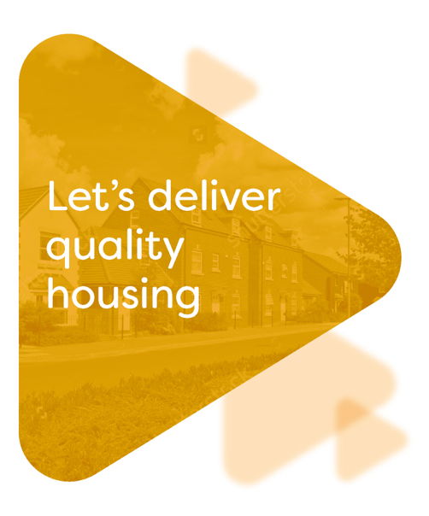



Contents

 | Page
Foreword | I
Executive summary | ii
Introduction: The City of Lincoln and its housing needs | 1
Objective 1: Providing housing which meets the varied needs of our residents | 9
Objective 2: Building sustainable communities | 13
Objective 3: Improving housing standards for all | 17
Figure 1: ONS map of the City | 1
Figure 2: Ward map of Lincoln | 1
Figure 3: Local Plan area | 2
Figure 4: Net housing numbers in the City of Lincoln 2015-19 | 2
Figure 5: Percentage tenure split | 2
Figure 6: Local authority housing stock (general needs and older persons’) | 3
Figure 7: Housing association general needs housing stock | 3
Figure 8: Homelessness applications | 4
Figure 9: Sustainable Urban Extensions | 13

Appendix I: Action plan

Foreword

A quality affordable home in which people can feel safe and thrive is a fundamental element in creating a sustainable community and enhancing society as whole. Our Housing Strategy sets out how we will work together with our partners across the public, private and voluntary sectors to meet housing demand and improve standards across all tenures in the city.

Whilst the strategy is for the period 2020-25, at present we do not yet fully understand the long-term effects of the current pandemic. Therefore, we can now only begin to recognise the emerging implications on the City’s housing market and the wider economy. For example, as some people’s work patterns shift to more flexible and home working, they may seek alternative larger housing, whereas, the recession is likely to lead to greater demand for affordable housing. It is essential for us to understand the ongoing impacts of Covid 19 in terms of central government policy and the local economy on Lincoln’s housing market.

Over the five-year period covered by the Housing Strategy, housing need across all tenures is likely to change, especially in light of changes to householders’ economic circumstances as a result of Covid-19 pandemic and the recession. In addition, the current planning reform proposals may impact on the delivery of the Strategy’s priorities. We will regularly monitor the evidence on which the Housing Strategy is based and produce an annual review, with revised and new priorities, which takes account of changing need and the revised policy agenda.

We recognise that there are often competing interests in facilitating the delivery of much needed housing for all our residents. The challenge of limiting the impact of new development on the environment is particularly important, especially in the light of the Council declaring a climate and environmental emergency. We understand that communities wish to see their physical environments protected and the challenge this presents in supporting new development.

We also recognise that in order to achieve economic growth, we need to facilitate the right homes to support growth and business development. It is also important to us that residents that require a special type of home with specific support are helped in equal measure. We are hugely ambitious and positive about the future and growth of housing in Lincoln and look forward to delivering this strategy.

Cllr Donald Nannestad

Deputy Leader and Portfolio Holder for Quality Housing



Executive summary

Lincoln is a growing and forward-looking city built on historic foundations and is the economic driver for the Lincolnshire area. With a population of just under 100,000, the cathedral City is a tourist destination and university town but also contains concentrations of deprivation.

Lincoln has a relatively high proportion of local authority and private rented accommodation, with below average levels of owner occupation. There is a need for additional housing across all tenures and for housing renewal in areas of deprivation.

The housing strategy seeks to deliver quality housing through three objectives:

Providing housing which meets the varied needs of our residents
The Council seeks to make best use of social housing stock through the implementation of a new allocations policy and the introduction of a nominations agreement. A Trusted Landlord Accreditation Scheme aims to improve standards in the private rented sector. The Council is delivering affordable and specialist housing to meet evidence need through planning policy, direct delivery and enabling.

Building sustainable communities
This is fundamental to delivering a housing strategy to meet the needs of the City. The City has ambitious plans for growth and is producing a Town Investment Plan. In addition to sustainable growth extensions, housing renewal and regeneration is planned for an area of the city centre which suffers from high levels of deprivation. The Council also seeks to balance the housing market through using planning policy and bringing empty homes into use.

Improving housing standards for all
The housing strategy seeks to improve housing standards across the City through the provision of aids and adaptations to promote independent living and energy efficiency measures to reduce fuel poverty and carbon emissions. With respect to council owned stock, the Council is to produce a revised HRA Business Plan, incorporating an asset management strategy. This will ensure that unsustainable and low demand housing, which does not meet modern standards and aspirations, is remodelled or redeveloped.

.

Introduction: The City of Lincoln and its housing needs

  - Lincoln is a growing and forward-looking city built on historic foundations and is the economic driver for Lincolnshire.

  - As a district council the City of Lincoln Council is both the Local Housing Authority and the Local Planning Authority, with Lincolnshire County Council having responsibility for social services and transport within the city.

Figure 1: ONS map of the City
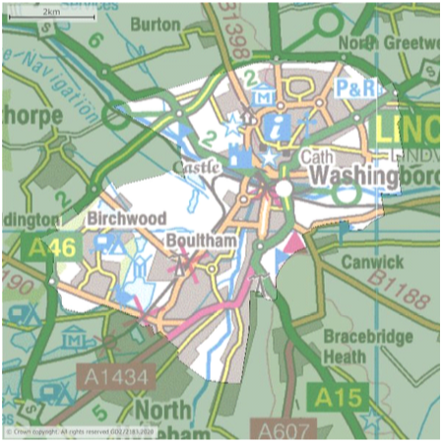
Source: NOMIS

  - It is estimated that the population of the City of Lincoln is 99,000 . The Ministry of Housing, Communities and Local Government statistics confirm that there are 44,140 dwellings in Lincoln, suggesting the average household size is around 2.2 persons.

  - Approximately 68% of the City’s population are aged 16 to 64 years; this compares to 63% of the national population; the reason for Lincoln’s high level of working age population being due to the impact of the student population. This is an important driver of housing growth, hence the need to facilitate a range of housing to meet the needs of a more youthful demographic, for example, mixed tenure city centre living.

  - The 2019 Index of Multiple Deprivation (IMD) found that ten of Lincoln’s 57 Lower Super Output Areas (LSOA) were in the 10% most deprived of the country. The main reason for deprivation being due to barriers to income, education, employment and health.

  - The main concentration of deprivation is in the Park Ward – this being the Sincil Bank residential area of the City, which is mixed tenure. Other Wards, including Birchwood, Moorland, Castle and Glebe also contain LSOAs with deprivation levels in the worst 10% of the country.

Figure 2: Ward map of Lincoln
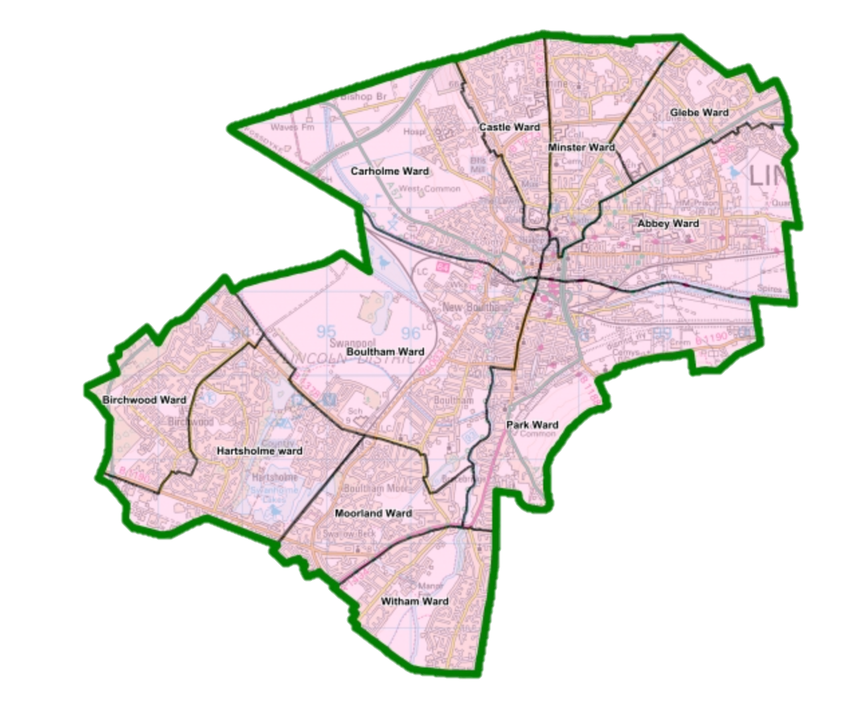

  - In 2019 the average full-time wage for people living in Lincoln was just below £27,000; this compares to the Greater Lincolnshire average of just over £27,500 and the national average of around £30,500. Given that Lincoln is the economic hub of the area, this could suggest that people living in City tend to be employed in less well-paid jobs, with the people undertaking the higher paid jobs living outside the City’s boundary.

  - At 0.93, compared to the Greater Lincolnshire and national figures of 0.79 and 0.86 respectively, the City has a high jobs density. Yet, paradoxically, the percentage of people claiming out of work benefits (the claimant count) is above the Greater Lincolnshire and national averages (6.8% as compared to 6.1% and 6.6% respectively). This suggests that either there is a need to upskill some residents to enable them to gain employment in the job market or instead some jobs may be economically unviable, so result in households remaining in the benefit trap.

  - The Central Lincolnshire Local Plan (CLLP), published in 2017, covers the City of Lincoln, West Lindsey and North Kesteven District Councils (Figure 3). Since 2012, on average 1,024 new homes have been delivered per annum in this Local Plan area.

  - However, as shown in Figure 4, since 2015 the City of Lincoln has had a very limited increase of housing delivery.

Figure 3: Greater Lincoln Local Plan area
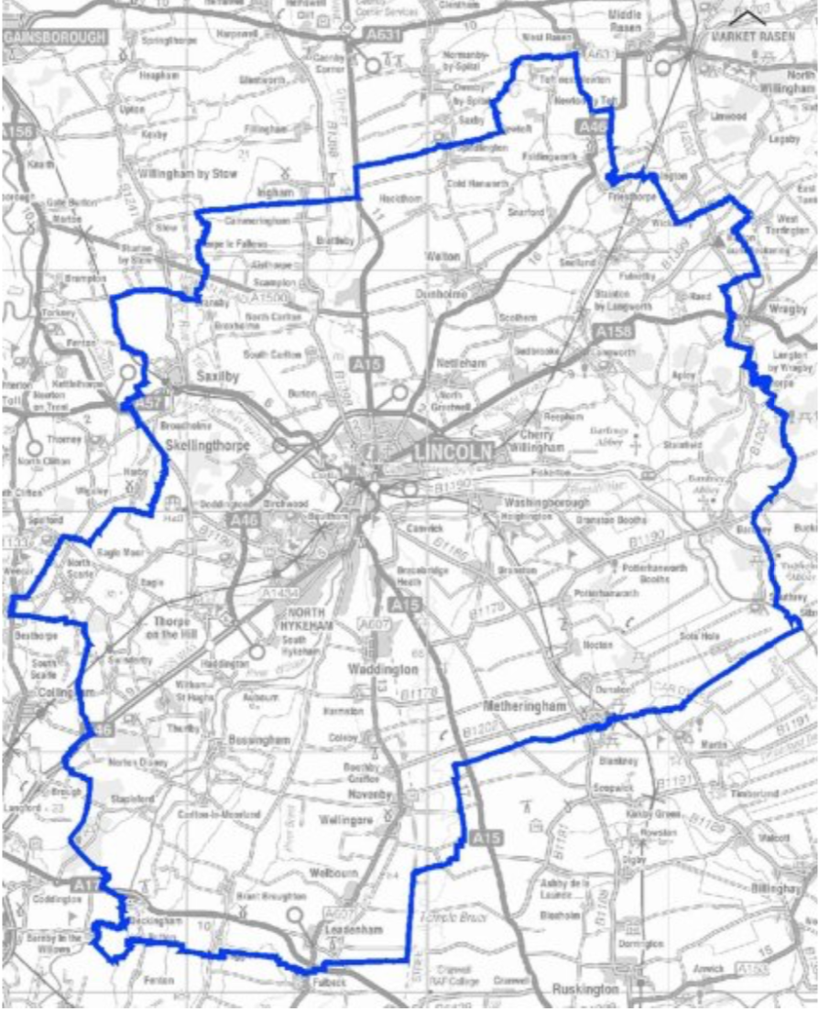

Figure 4: Net housing numbers in the City of Lincoln 2015-19
Date | Total Housing stock | Net Increase Per Year
April 2015 | 43,620 | 130
April 2016 | 43,750 | 130
April 2017 | 43,880 | 130
April 2018 | 44,140 | 260
April 2019 | 44,509 | 369
Source: MHCLG

  - There are an estimated 425 long-term empty homes at any one time in the City, representing 1% of Lincoln’s housing stock. Although, as compared to other urban conurbations this is comparatively low, it is important to recognise that many empty homes are a wasted resource, especially when there is high demand for housing.

  - With respect to housing tenure, as shown in Figure 5, the 2011 census shows that Lincoln has a lower proportion of owner occupiers, but higher proportions of those in social and private renting as compared with England and Wales.

Figure 5: Percentage tenure split

Source: 2011 census

  - A key reason for the comparatively high level of private renting is due to the City’s student population (17,225) and the number of Houses in Multiple Occupation (HMOs) – currently estimated to be 900. Reasons for the below national levels of home ownership include the level of unemployment, income levels and the City’s demographics.

  - With respect to affordable housing, Lincoln has just over 7,800 local authority and around 1,500 housing association dwellings for rent, the latter provided by 15 housing associations. This includes just over 1,100 general needs dwellings, almost 200 sheltered dwellings for older persons and just over 350 units (flats and bed-spaces of supported accommodation, including hostel bed-spaces). In addition, housing associations provide around 300 homes for shared ownership. Stock breakdowns are set out in Figures 6 and 7 below.

Figure 6: Local authority housing stock (general needs and older persons)
Housing / bedrooms | 0 | 1 | 2 | 3 | 4+ | Totals
Bedsit | 104 |  |  |  |  | 104
Bungalow |  | 341 | 179 | 62 |  | 582
Flat |  | 2663 | 621 | 18 |  | 3302
House |  | 15 | 1735 | 1665 | 146 | 3561
Maisonette |  |  | 249 | 16 |  | 265
Totals | 104 | 3019 | 2784 | 1761 | 146 | 7814

  - As can be seen from Figure 6, 35% of local authority housing stock comprise bedsits and flats; 46% houses; and only 7% bungalows. This is mainly due to previous funding opportunities and the impact of the Right to Buy (50 to 60 dwellings are sold per year).

Figure 7: Housing association general needs housing stock
Housing / Bedrooms | 0 | 1 | 2 | 3 | 4 | Totals
Bedsit | 28 |  |  |  |  | 28
Bungalow |  | 40 | 28 | 6 |  | 74
Flat |  | 290 | 140 |  |  | 430
House |  | 31 | 311 | 223 | 10 | 575
Maisonette |  | 1 |  |  |  | 1
Totals | 28 | 362 | 479 | 229 | 10 | 1108

  - In 2018 11% of households in Lincoln were in fuel poverty, this has reduced from 11.6% in 2014 and 19.3% in 2011. The majority of fuel poor households are in the private sector. As is the case in other urban areas, a key reason for fuel poverty is people on low incomes living in pre-1919 accommodation.

  - Private sector housing stock condition modelling was undertaken in 2017. This modelling estimated that 15% of stock had category 1 housing health and safety hazards under the Housing Health and Safety Rating System (HHSRS). The highest concentration of which were located in wards of Park, Carholme and Abbey.

  - In terms of energy efficiency, it was estimated that almost 1,200 dwellings in the private sector, including over 600 private rented dwellings had an EPC rating below band E.

  - Local authority and housing association stock is required to meet the Decent Homes Standard. At March 2020 0.5% of local authority housing failed meet the Decent Homes Standard, although work programmes were in place to rectify this.

  - In June 2020 the average sale price for a residential property in Lincoln was £161,040, up 3.9% on the previous year, as compared to £237,834in the UK, an increase of 3.4% on the previous year.. This increase in house prices highlights that demand for residential property in the City remains high.

  - In 2019 the ratio of median house price to median gross annual workplace-based earnings was 5.79 (as compared to 7.83 for England) and the ratio of lower quartile house price to lower quartile gross annual workplace-based earning was 6.3 (as compared to 7.27 for England). This suggests that there is insufficient housing stock available for sale at the lower end of the housing market, leading to these house prices being artificially inflated.

  - Often people understand homelessness as when individuals or families are rough sleeping or roofless. The definition of homeless is far wider than this and also considers whether the Council owes a household a statutory duty, with the main or full duty being for the Council to ensure the household has suitable accommodation.

  - When comparing the incidence of homelessness in Lincoln to England as a whole it is clear that on a household basis, Lincoln has above average numbers of applications for assistance. This is likely to relate to Lincoln being the city for wider Lincolnshire. Figure 8 shows data for the third quarter of 2019-20.

Figure 8: Homelessness applications
Criteria | Number of households | Variance from England average
Total households assessed under Housing Act 1996 | 162 | +51%
Threatened with homelessness - prevention duty owed | 58 | +22%
Homeless - relief duty owed | 102 | +105%
Single person owed relief duty | 32 | +119%
Single parent with dependent children | 22
Source: MHCLG and ONS

  - This proportionally high number of applications under the Housing Act not only results in high levels of investigatory work, but the need to often place households in temporary accommodation whilst this is undertaken.

  - With respect to rough sleepers, 2018 count estimated that the City had 26 rough sleepers on any one night. This equates to 6.3 per 10,000 households and is a variance of +215% from the England figure of 2.0 per 10,000 households. The 2019 estimate for Lincoln increased to 27 rough sleepers.

  - The Lincolnshire Rough Sleeping Strategy 2019-2021 identifies the reasons for the high numbers of rough sleeper due to: changes in welfare and housing benefits; the reduction of health services and supported housing; and the large hospital and prison both releasing people without suitable accommodation. In addition, the provision of services in Lincoln acts as a magnet for many people from out of the area.

  - In response to the Covid19 pandemic the Government introduced changes to homelessness legislation which widened the definition of priority need based on a person’s vulnerability. This resulted in a number of rough sleepers being eligible for emergency accommodation. As a result, the Council was able to provide rough sleepers with emergency accommodation. At August 2020 the number of rough sleepers in Lincoln was 16, however, it is likely that these are people who were not previously rough sleeping in the City.

  - The Council is anticipating that there is a high risk that all forms of homelessness, including rough sleeping, will increase due to the recession. Therefore, it is essential the Council continues to both prevent and tackle all forms of homelessness.

  - The Council’s 2019 housing needs survey provides a wealth of information at a City level. It estimated that:
- 2,500 homeowners find it difficult to maintain their home;
- 700 households find their mortgage payments too expensive;
- a third of households who are privately renting find their rent too expensive;
- 9,200 households find the cost of their utility bills to be a problem, with the private rented sector containing a disproportionate amount of these households;
- 3,500 households contain people who have difficulty with stairs or a lift, with a disproportionate number (1,300) living in local authority housing;
- 13,000 people have support needs due to having a medical condition, a physical, sensory or learning disability, or being frail elderly;
- 10,300 existing households plan to move in the next five years, this includes approximately 3,700 households who are privately renting, 2,400 households who own their home outright, 2,800 households who have a mortgage and 1,000 households in local authority housing;
- 4,500 concealed households plan to move in the next five years;
- 9,000 existing and concealed households planning to move in the next five years intend to remain living in the City of Lincoln;
- 3,600 households planning to move intend to purchase a property, 1,600 wish to rent from the Council and 500 intend to rent in the private sector;
- 900 households who are currently private renting intend to buy with a mortgage and almost 700 wish to rent from the Council; and
- 600 households who own their homes outright plan to buy a bungalow in the next five years.

  - In terms of cross-tenure housing demand, the housing needs survey indicated that a mix of 65% houses, 25% bungalows and 10% flats is required to meet need. When looking at the demand for affordable rented accommodation the proportion of bungalows increases to around 40%, flats increase to 20% and houses decrease to 40%.

  - In 2019 a review of housing / accommodation need for older people report commissioned by Lincolnshire district authorities found that Lincoln has an over-supply of residential and nursing homes. However, Lincoln has a shortfall of housing designed for older people in both the private and social sectors.

  - As part of the Central Lincolnshire Local Plan review a Gypsy and Traveller Accommodation Assessment (GTAA) was completed in March 2020. Currently Lincoln has one official local authority owned site with 19 pitches, of which 7 are occupied and 12 pitches are either vacant or are potential pitches.

  - Based on the assessment for future accommodation needs for the permanent Gypsy and Traveller community there are surplus pitches in Lincoln until 2040. However, there is currently no provision for temporary stopping sites for the seasonal travelling community, who need to travel for economic or work purposes. As a result, there have been 18 unauthorised encampments between April 2016 and August 2019 within Lincoln.

  - As part of the review of the Central Lincolnshire Local Plan a Housing Needs Assessment (HNA) has been produced in April 2020. The HNA highlights a sizeable need for two-bedroom properties (28%) and homes with at least four bedrooms (22%) across Central Lincolnshire. Substantially fewer households (7%) would be expected to need only one bedroom, albeit acknowledging that this is influenced by the stock of housing that is currently available. It is estimated that meeting this need could require over two thirds (69%) of new homes to be houses, surpassing the more limited need for bungalows (20%) and flats (11%).

  - The HNA, using the Standard Methodology for calculating affordable housing need, provides a gross affordable housing need in Lincoln of 922 dwellings over a five-year period. The net affordable housing need is then calculated by subtracting the anticipated pipeline of existing and new affordable housing. This net figure (described as a shortfall) is 334 dwellings over a five-year period.

  - When taking into account the cost of renting or purchasing a property against average income the HNA suggests that 49% of newly forming households will not be able to afford to purchase on the open market; and 39% of newly forming households will not be able to afford either to purchase or rent on the open market.

  - The HNA will provide evidence of need to inform housing allocations and other associated Local Plan Policies.

  - The Joint Strategic Needs Assessment (JSNA) for Lincolnshire advises that it is important that the right homes are available, accessible, in the right place, in good condition, warm and are affordable.

  - Lincolnshire County Council is currently establishing the level of housing need for people with learning disabilities and for people with mental ill health, so as to ensure the district authorities (including City of Lincoln Council) can enable suitable supported and specialist housing to meet identified need. This, and other housing needs information, will form part of the Lincolnshire Homes for Independence strategy. The document aims to set out the requirements of vulnerable people whose housing needs are not met by the housing market.

  - Since the launch of the last housing strategy in 2017, the Council has made great progress, including:
- delivering over 200 additional local authority dwellings through new build and acquisition;
- enabling approximately 150 housing association dwellings for rent and shared ownership;
- bringing 137 empty homes back into use;
- starting on site at the 70 unit extra care sheltered housing scheme at De Wint Court and a five general needs houses at Markham House;
- delivering a Rogue Landlord Scheme; and
- continuing to promote and increase membership of the Trusted Landlord Scheme.

  - We need to be proud of our achievements, but not lose sight of our 2025 strategic priority, let’s deliver quality housing.

  - This strategic priority has five aspirations:
- Let’s provide housing which meets the varied needs of our residents
- Let’s work together to tackle homelessness in Lincoln
- Let’s improve housing standards for all
- Let’s build thriving communities
- Let’s help people have a sense of belonging

  - The 2020-25 housing strategy seeks to deliver quality housing through three objectives:
- Providing housing which meets the varied needs of our residents
- Building sustainable communities
- Improving housing standards for all

  - Ensuring people have a sense of belonging and preventing homelessness cut-across these objectives.

  - It is vital that the vision and the objectives are not just words but become reality. This means making best use of available resources and ensuring investment is aligned to delivery these strategic aims.

  - Given the impact of Covid 19 upon peoples’ lives and the economy, including homelessness and unemployment, the role of the housing strategy is extremely important. Housing is more than just bricks and mortar; housing renewal and the delivery of the right housing in the right place not only creates sustainable communities, but also supports the economic recovery.

  - Moving forward the role of housing will change as it will not only be needed to provide in its most basic sense accommodation to meet need, but to stimulate the economy.

Objective 1: Providing housing which meets the varied needs of our residents

Our goals for 2025 are to:
- Make the best use of housing stock through the allocation of local authority housing and nominations to housing associations and promotion of the private rented sector.
- Prevent homelessness, and when people are homeless ensure that through partnership working ensure that we have sufficient suitable accommodation to meet needs
- Maximise the delivery of affordable housing through both direct delivery and enabling, including the remodelling and redevelopment of low demand local authority housing stock.

What success will look like in five years:
We will have a range of housing options for people in housing need. Through homelessness prevention and intervention work we will reduce the level of homelessness, including rough sleeping. Homeless households will be placed in suitable accommodation to meet needs. We will have increased the level of affordable housing stock, both local authority and housing association, to meet housing need. We will have an ongoing plan of remodelling and redevelopment works to local authority stock to ensure housing meets aspirations and is fit for purpose.

Where are we now and what we will do to achieve this?

  - In early 2020 there were almost 1,400 applicants on the Council’s housing register for local authority housing. However, a new Allocations Policy is to be introduced which requires that, subject to certain exceptions, applicants have a two-year residency connection to the City of Lincoln. This is to ensure that social housing is offered to those with the highest housing needs, whilst also meeting the needs of local people.

  - Nomination rights with housing associations are being reviewed and formalised, in order to ensure that a percentage of housing association lettings are allocated to applicants on the Council’s housing register.

  - To complement the introduction of a revised allocations policy and the reinvigoration of nominations, the Council is to produce a city-wide Tenancy Strategy which will set out the types and lengths of tenancies offered by the Council and all housing associations operating in the City.

  - In order to improve the standard of private rented accommodation, housing management and neighbourhood relations, the Council operates a Trusted Landlord Accreditation Scheme. As of March 2020, 36 private landlords and agents were accepted as members or affiliate members of the scheme.

  - Given the comparably high levels of homelessness and rough sleeping found in the City, the Council is to produce a city-wide Homeless Prevention Strategy. An initial action has been the creation of an in-house temporary accommodation scheme, which aims to ensure that bed and breakfast accommodation is only used in emergencies.

  - When considering turnover of local authority housing stock, the 2019 housing needs survey, homelessness statistics and the impact of the Right to Buy, over the next five years there is an indicative need for the Council and its housing association partners to deliver over 300 bungalows (or alternative retirement housing) and around 700 general needs houses.

  - Housing churn and long-term empty local authority dwellings evidence the difficulty in letting bedsit schemes for older people and general needs maisonettes and some flats, notably those in high rise blocks. When comparing projected turnover against housing need, this suggests that over a five-year period due to oversupply there is a need to remodel or redevelop around 600 existing bedsits, flats and maisonettes.

  - In order to meet evidenced housing need the Council uses planning policy, direct delivery and enabling to delivery new affordable and specialist housing.

  - The Affordable Housing Policy requires, subject to financial viability, 25% of dwellings on sites of 11 or more dwellings to be affordable, with this reducing to 20% of dwellings developed in Sustainable Urban Extensions.

  - A priority is to increase the enabling work with housing associations, private developers and private landlords to influence provision of additional affordable homes to meet need. A new Supplementary Planning Document (SPD) on Affordable Housing forming part of the revised Local Plan will further facilitate this.

  - It is recognised that proposed planning reform not only looks to categorise land, thus require a new Local Plan, but also change the current policy approach to affordable housing and developer contributions.

  - The Council’s New Homes Programme delivers affordable housing through direct delivery and acquisitions:
- the purchase and repair of 30 dwellings during 2020-21;
- a scheme of five family houses, funded through retained Right to Buy receipts, at the former site of Markham House is to complete in Autumn 2020;
- the Council acquired 15 family houses from a partner housing association (developed with Homes England grant) on Sandal Street, off Riseholme Road, in Summer 2020;
- a proposed scheme of approximately 40 general needs houses, flats and bungalows for affordable rent and shared ownership at Rookery Lane to start on site in Spring 2021;
- proposed additional family housing at Hermit Street;
- a proposed mixed tenure development on Council owned land north of Queen Elizabeth Road, anticipated to provide circa 100 units of affordable housing for rent and shared ownership;
- a proposed mixed tenure development, to include older persons affordable housing, at Searby Road; and
- a number of potential small infill developments to provide general needs and specialist housing.

  - In order to meet a range of needs of older people the Council is developing a 70 unit extra care sheltered housing scheme at De Wint Court. The scheme is due to complete in late 2021, it has received grant funding from Homes England and Lincolnshire County Council.

  - The Council works in partnership with Lincolnshire County Council to meet the housing needs for all vulnerable groups in Lincoln. This includes people with learning disabilities and people with mental ill health.

  - A key action of the Council’s Temporary Accommodation Strategy is to develop a supported housing scheme for single homeless people. Moreover, linked to this is the need to develop move-on accommodation.

  - In order to tackle unauthorised Gypsy and Traveller encampments the 2020 GTAA recommends that the Council adopt a negotiated stopping policy which identifies suitable locations for temporary stopping sites for an agreed and limited period of time with services.

  - The Birchwood CLT is seeking to create affordable homes and recreational space on an underused council owned site at Jasmine Green to meet housing need for older people and families.

Providing housing which meets the varied needs of our residents: Priorities for action
- Implement the revised local authority housing allocations policy
- Review and establish formal nominations agreements with housing associations
- Produce a City of Lincoln tenancy strategy
- Increase the membership of the Trusted Landlord Accreditation Scheme
- Produce a City of Lincoln homelessness prevention strategy
- Produce an Affordable Housing Supplementary Planning Document
- Continue to increase the local authority housing stock through the purchase and repair programme
- Deliver affordable housing at Markham House
- Deliver affordable housing at Rookery Lane
- Deliver additional affordable housing at Hermit Street
- Produce a master plan for Queen Elizabeth Road and surrounding area
- Deliver a mixed tenure scheme at Queen Elizabeth Road
- Produce a master plan for Searby Road and surrounding area
- Deliver a mixed tenure housing scheme at Searby Road
- Maintain a list of potential infill developments and a Brownfield Sites Register
- Deliver the De Wint Court extra care sheltered housing scheme
- Establish the housing needs of people with learning disabilities
- Establish the housing needs of people with mental ill health
- Deliver a temporary accommodation scheme for single homeless persons
- Deliver move-on accommodation for former homeless households
- Respond to the Gypsies and Traveller Accommodation Needs Assessment
- Deliver affordable housing at Jasmine Green
- To review the implications of the recession and Covid19 pandemic to understand and respond to changes in housing need.

Objective 2: Building sustainable communities

Our goals for 2025 are to:
- Make progress on delivering the Western Growth Corridor to provide mixed tenure housing to meet need and demand
- Facilitate city centre living in Lincoln, ensuring that the city centre remains a vibrant and attractive place to live.
- Continue to work with residents and strategic partners to deliver the Sincil Bank Revitalisation Programme, including the regeneration of Hermit Street.
- Continue to work with our tenants to deliver estate improvements and an improved street scene.
- Bring more empty homes back into use, to provide housing and improve the built environment.
What success will look like in five years:
The Western Growth Corridor will be under-way to providing a variety of homes. Our city centre will be vibrant and attract to live in. We will have revitalised Sincil Bank, with new affordable homes for families, safer cycling and pedestrian routes and improved standard of private rented accommodation for all. We will have a programme of where we need to facilitate neighbourhood and housing renewal. Our local authority housing estates will have an improved street scene.

Where are we now and what we will do to achieve this?

  - The Greater Lincolnshire Housing Delivery action plan sets out an ambitious programme to enable and deliver more homes in Lincolnshire.

  - The Central Lincolnshire Local Plan identifies a housing requirement for, approximately 1,323 dwellings per annum are indicated as being needed between 2020 and 2044. Fundamental to delivering these housing numbers are the Plan’s four Sustainable Urban Extensions (SEUs).

Figure 9:Sustainable Urban Extensions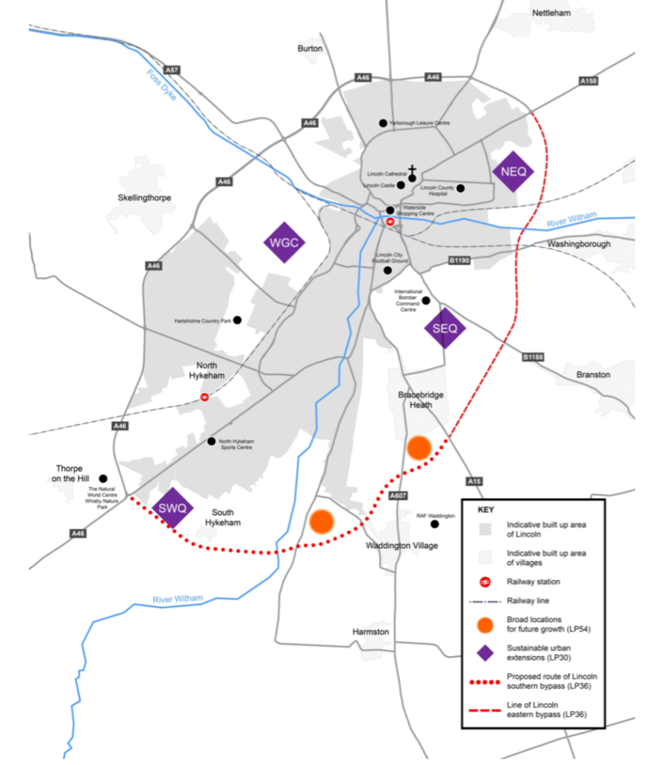

  - As shown in Figure 9 these four SEUs are:
- WGC – Western Growth Corridor;
- NEQ – North Eastern Quadrant;
- SEQ – South Eastern Quadrant; and
- SWQ – South Western Quadrant

  - In developing a strategy to support growth, the City Council has commissioned the University of Lincoln to review the economic evidence, which alongside transport and digital infrastructure and skills evidence, will inform the production of a Town Investment Plan. This plan will, within the national and regional context, set out a clear vision, opportunities and challenges for the City’s growth, and set out priorities for investment over the next five years.

  - A key objective is to encourage and enable the construction industry to provide training and development opportunities, including apprenticeships, across all trades and professions. Therefore, the need to ensure that sufficient resources, in terms of finance and training, are available.

  - In May 2019 the Council submitted a planning application for up to 3,200 homes to be built on the Western Growth Corridor. The development will provide up to 640 affordable homes.

  - In addition to the Western Growth Corridor sustainable urban extension, an important strategic aim is to facilitate city centre living in order to drive economic regeneration to ensure Lincoln is a thriving place to live and work. City centre living not only provides housing for a range of people, including young professionals, but encourages a vibrant city centre, especially in light of the impact of Covid 19 and the national phenomenon of the “death of the high street”.

  - The Council is considering a range of opportunities as an enabler and direct provider. A key priority is the redevelopment of a large city centre site which is currently used as a carpark to provide a mixed tenure development to meet need and attract additional demand into the centre of the city.

  - A further element of promoting and facilitating city centre living is the submission of a funding bid under the Town Deal Programme.

  - In addition to economic regeneration, place-based renewal and housing regeneration is being undertaken in Sincil Bank – an area which suffers from deprivation due to barriers to income, education, employment and health.

  - The Sincil Bank neighbourhood renewal programme includes a range of activities and projects to re-establish Sincil Bank as a community with homes and an environment residents’ can be proud of.

  - In 2019 the Sincil Community Land Trust (SCLT) became incorporated and registered with the Financial Services Authority. A key aim of the SCLT is to bring homes in the area back into use.

  - Estate regeneration is in initial stages at Hermit Street, Sincil Bank. The design of the regeneration scheme has been community-led. It seeks to regenerate local authority flats and garages on Hermit Street which are target for crime and anti-social behaviour and to better meet housing need. The concept site designs have been completed providing an excellent basis on which to move forward.

  - Other areas in the City suffer from deprivation, therefore, the Council will undertake mini neighbourhood renewal assessments to establish the investment options for undertaking place-based renewal and regeneration.

  - Walks around local authority estates, some of which suffer from high levels of deprivation have found that there is a need to:
- improve the level of off-street parking;
- improve street and building signage;
- make better use of community space;
- improve green areas; and
- ensure residents maintain their gardens.

  - These estate improvements and management issues will be considered in the new HRA Business Plan and the updated Resident Involvement Strategy.

  - A review of local authority garage and other infill sites has identified opportunities to improve, demolish and redevelop sites which are not fit for purpose and attract anti-social behaviour. Allowing for them to be considered for housing and other community uses.

  - The high level of student housing in the City has resulted in high concentrations of HMOs in particular localities. In order to attempt to rebalance the housing market an Article 4 Direction under the Town and Country Planning legislation is in place. The development of purpose-built student accommodation will mean that by 2026 the demand of HMOs from students will have greatly reduced, allowing for the reintroduction of family housing and more balanced residential neighbourhoods.

  - The Council has an Empty Homes Strategy, enabling the council to use a range of enforcement powers to bring empty homes, in private sector ownership, back into use. The Council’s target is to bring 25 homes back into use per annum and an aspirational target of 50 homes per annum. An action plan for all homes empty for two or more years is in place. The outcome been to bring a total of 46 empty homes back into use during 2019-20.

  - In April 2020 the Council introduced a 300% Council Tax rate for homes empty for over five years, this will affect 46 properties. The Council has the powers to increase Council Tax to 400%, this will be reviewed and considered if further enforcement action is required.

  - Since 2008 Openreach, as part of the Onlincolnshire project, has been delivering a programme to expand superfast broadband, with 99.6% of Lincoln now having access to higher broadband speeds (above 15 Mbps). As reliance on digital technology increases with more people working and studying from home, the increase of health and public services being accessed online and rapid increase in the internet of things (IoT), it is essential to ensure that all areas of the city have reliable access to superfast broadband.

  - The Council will continue to work to ensure that new housing developments and existing residential areas have access to superfast broadband to keep up with ongoing digitalisation.

  - The Greater Lincolnshire One Public Estate (GLOBE) is committed to use the public estate to drive integrated services and use surplus public land to deliver the GLLEP’s housing and economic agenda. The City of Lincoln Council are committed to supporting GLOBE objectives. GLOBE is considering the response to Covid 19 and the possible change in demand for city centre office space with a view to repurposing public buildings to provide an increase in city centre housing provision.

Building sustainable communities: Priorities for action
- Produce Town Investment Plan
- Encourage and enable the construction industry to provide training and development opportunities
- Deliver the Western Growth Corridor
- Deliver city centre living at Tentercroft Street
- Submit Town Deal bid
- Continue to undertake neighbourhood working at Sincil Bank
- Continue to work with the Sincil Community Land Trust to develop community-led housing and open space projects
- Deliver estate regeneration at Hermit Street, including the provision of additional housing to meet local need
- Undertake mini neighbourhood renewal assessments in areas of high social deprivation.
- Review and update the Resident Involvement Strategy
- Maintain City of Lincoln Council representation on Greater Lincolnshire District Housing Network and Affordable Housing Group.
- Continue to review ongoing changes in housing demand and to repurpose public buildings where appropriate.
- Continue to support the Climate and Environmental emergency through improving energy efficiency of buildings, assisting residents to access funding and support to improve the energy performance of their homes and ensure access to superfast broadband.

Objective 3: Improving housing standards for all

Our goals for 2025 are to:
- Support residents to improve the energy efficiency of their homes in order to reduce the number of households living in fuel poverty and reduce Lincoln’s carbon footprint.
- Continue to enable vulnerable residents to live independently through the provision of aids, adaptations and other assistance.
- Ensure local authority housing stock is maintained to a high standard, meets modern aspirations and is sustainable in the longer term.
What success will look like in five years:
We will have fewer people living in fuel poverty, reduce Lincoln’s Carbon Dioxide emissions and increase the overall quality of housing stock to meet the City’s housing needs.

Where are we now and what we will do to achieve this?

  - The Council’s Private Housing Health Assistance Policy (2018-2022) offers support for owner occupiers, private and housing association tenants.

  - The policy delivers Disabled Facilities Grant (DFG) and discretionary assistance schemes to fund adaptions and other measures to enable people to remain living in their own homes.

  - Adaptations range from installing level access showers, ramps, to stair lifts through to new boilers. It is estimated that there is a need for 53 DFGs per year. During 2019-20 the council approved 58 DFGS. Over the period 2020-25 it is anticipated that, dependent on funding, the Council will approve 265 DFGs.

  - The Housing Health and Care delivery group are in the process of developing a common Lincolnshire Housing Assistance Policy, covering hospital discharge, discretionary funding grants to apply to all district councils. In addition to a common Lincolnshire policy, Lincoln will still have its own local policy to cover additional services offered to support Lincoln’s residents.

  - The Council’s Affordable Warmth Strategy seeks to reduce the proportion of households in fuel poverty. During 2020-21 the strategy will be reviewed and revised to include the Council’s involvement with the Greater Lincolnshire Energy efficiency Network and the Health and Housing Assistance Policy.

  - The Greater Lincolnshire Energy Efficiency Network (GLEEN) is a partnership of the seven district, North East Lincolnshire, North Lincolnshire and Lincolnshire County Councils under which domestic energy efficiency schemes are delivered across the Greater Lincolnshire area. During 2020 GLEEN will set up and deliver the Lincs 4 Warmer Homes Scheme, providing an advice service for residents to enable them to access the Government’s ECO3 Help to Heat funding and the Warm Homes Fund. Funding is available to help households living in fuel poverty, living on a low income and vulnerable to the effects of a cold home, improve the energy efficiency of their home.

  - Currently there are in the region of 5,000 households living in fuel poverty in Lincoln. Over the period 2020-25 the City of Lincoln Council will work to reduce this number by promoting the Lincs 4 warmer homes scheme to householders in private sector properties with a SAP rating of D or below and on means tested benefits or low income and people who are vulnerable to the cold.

  - As stated earlier in this document, as of March 2020 0.5% of local authority housing failed to meet the Decent Homes Standard. All failing elements will be rectified or replaced during 2020-21, complete with other planned and cyclical works to ensure the Decent Homes Standard is maintained across the whole of the Council’s housing stock.

  - Moreover, the Council has its own “Lincoln Homes Standard” which incorporates the national Decent Homes Standard. 2020 will see a review of the Lincoln Homes Standard which will incorporate external elements, such as communal areas and outside spaces.

  - Let’s address the challenge of climate change is one of the Council’s strategic priorities. In 2019 the Council declared a Climate and Environmental Emergency and set an aspirational target to achieve a net zero target by 2030 for Lincoln. In order to achieve this target, the Council has reviewed its housing repair service to identify opportunities for a more sustainable practice. In 2020-21 the Council will review the energy efficiency of its housing stock and identify opportunities to further improve the SAP rating of council homes.

  - The results of the 2020 local authority stock condition survey which was based on a ten per cent sample of stock stratified by architype, are to be considered against existing data and will provide a robust database of stock condition information.

  - When considering housing need and affordable housing demand identified by the housing needs survey, the Council’s housing register and the turnover of local authority housing stock, the evidence highlights the need for redevelopment or remodelling of two dwelling typologies – sheltered bedsits and one bedroom general needs flats in two of the City’s high rise blocks - so as to provide sustainable housing to meet aspirations.

  - Therefore, with respect to asset management, there is a need for the Council to consider the future life term of its two sheltered bedsit schemes and two out of its three high rises. In addition, there are a number of prefabricated bungalows which do not meet reasonable energy efficiency standards which could be redeveloped to provide a greater number of high-quality dwellings to meet the identified need.

  - A revised HRA Business Plan will be produced in 2020-21 which will incorporate: the findings of the 2020 stock condition survey; the asset management issues identified by the 2019 housing needs survey and the housing register; and reflect the climate change agenda.

  - In response to the council’s climate emergency declaration and to support Lincoln’s green recovery post Covid19, the council will identify opportunities to support all residents to access necessary funding and support to improve the energy efficiency of their homes. Currently this is achieved through a consortium arrangement set up through the Lincs4warmer homes scheme and close working with the East Midlands Energy Hub.

Improving housing standards for all: Priorities for action
- Review and update the Private Housing Health Assistance Policy.
- Review and update the Affordable Warmth Strategy
- To continue to work with the Greater Lincolnshire Energy Efficiency Network to deliver the Lincs 4 warmer homes scheme and to maximise funding opportunities to improve energy efficiency wherever possible
- Undertake an options appraisal of sheltered housing bedsit schemes
- Undertake an options appraisal of two high rise schemes
- Undertake an options appraisal of prefabricated bungalows
- Produce a revised HRA Business Plan which includes an asset management strategy
- Continue to work with the Greater Lincolnshire Energy Efficiency Network to deliver the Lincs 4 warmer homes scheme and to maximise funding opportunities to improve energy efficiency wherever possible
- To work with the Housing Health and Care Delivery Group on a delivery plan and common Lincolnshire Housing Assistance Policy.

Please see Appendix 1 for a detailed action plan.

Appendix I: Action Plan

Action | Priority Objective - Providing housing which meets the varied needs of our residents | Year: 2020/2021 | Year: 2021/2022 | Year: 2022/2023 | Year: 2023/2024 | Year: 2024/2025 | Outcome | Responsible Officer
1.1 | Implement the revised local authority housing allocations policy. | Policy implemented |  |  |  |  | To provide affordable homes for those with the highest housing needs. | Alison Timmins, Housing Solutions
1.2 | Review and establish formal nominations agreements with housing associations | Review existing agreements | Establish new agreement |  |  |  | Maximising access to affordable housing to those in need. | Melanie Holland, Housing Strategy and Investment Team
1.3 | Produce a City of Lincoln tenancy strategy |  | New strategy agreed |  |  |  | A strategy which sets out the tenancy arrangements for the Council and all the housing associations operating in the City. | Melanie Holland, Housing Strategy and Investment Team
1.4 | Increase the membership of the Trusted Landlord Accreditation Scheme | Ongoing | Ongoing | Ongoing | Ongoing | Ongoing | Making best use of the private rented housing stock across the City to meet housing need | Joanna Gray, Private Housing Team
1.5 | Produce a City of Lincoln homelessness prevention strategy |  | Strategy produced |  |  |  | A toolbox of multi-agency approaches to prevent homelessness | Alison Timmins, Housing Solutions
1.6 | Produce an Affordable Housing Supplementary Planning Document |  | Draft produced |  |  |  | To maximise the provision of affordable housing. | Melanie Holland, Housing Strategy and Investment Team
1.7 | Continue to increase the local authority housing stock through the purchase and repair programme | Deliver 30 units |  |  |  |  | To deliver additional affordable housing to meet housing need. | Melanie Holland, Housing Strategy and Investment Team
1.8 | Deliver affordable housing at Markham House | PC |  |  |  |  | To deliver additional affordable housing to meet housing need. | Joanna Walker/Jenny Crane, Major Developments team
1.9 | Deliver affordable housing at Rookery Lane |  | SoS | PC |  |  | To deliver additional affordable housing to meet housing need. | Joanna Walker/Jenny Crane, Major Developments team
1.10 | Deliver additional affordable housing at Hermit Street | Agree proposals | SoS | PC |  |  | To deliver additional affordable housing to meet housing need. | Kate Bell, Housing Strategy and Investment Team
1.11 | Produce a master plan for Queen Elizabeth Road and surrounding area | Agree master plan |  |  |  |  | Master plan which meets housing need and enables the delivery of a flagship mixed tenure scheme. | Melanie Holland, Housing Strategy and Investment Team
1.12 | Deliver a mixed tenure scheme at Queen Elizabeth Road | Soft market test | Procure partner(s) | SoS |  |  | Delivery of a flagship mixed tenure scheme meet housing need. | Joanna Walker/Jenny Crane, Major Developments team
1.13 | Produce a master plan for Searby Road and surrounding area |  | Agree master plan |  |  |  | Master plan which meets housing need and enables the delivery of a flagship mixed tenure scheme. | Joanna Walker/Jenny Crane, Major Developments team
1.14 | Deliver a mixed tenure housing scheme at Searby Road |  |  | SoS | PC |  | Delivery of a flagship mixed tenure scheme meet housing need. | Joanna Walker/Jenny Crane, Major Developments team
1.15 | Maintain a list of potential infill developments and a Brownfield Site Register. | Ongoing | Ongoing | Ongoing | Ongoing | Ongoing | List of potential infill development sites. Publication and maintenance of Brownfield Site Register on Council’s website. | Toby Forbes Turner, Planning Policy
1.16 | Deliver the De Wint Court extra care sheltered housing scheme |  | Project Complete |  |  |  | Additional specialist affordable housing to meet housing need. | Tracey Footsoy, Housing Strategy and Investment Team
1.17 | Establish the housing needs of people with learning disabilities |  | Housing needs identified |  |  |  | Housing needs assessment which provides needs for 3 to 5 years | Melanie Holland, Housing Strategy and Investment Team
1.18 | Establish the housing needs of people with mental ill health |  | Housing needs identified |  |  |  | Housing needs assessment which provides needs for 3 to 5 years | Melanie Holland, Housing Strategy and Investment Team
1.19 | Deliver a temporary accommodation scheme for single homeless persons |  | SoS | PC |  |  | Specialist housing to meet housing need. | T Melanie Holland, Housing Strategy and Investment Team
1.20 | Deliver move-on accommodation for rough sleepers |  | SoS |  |  |  | Additional supported housing to meet housing need | Melanie Holland, Housing Strategy and Investment Team
1.21 | Respond to the Gypsies and Traveller Accommodation Needs Assessment | Assessment complete | Ongoing | Ongoing | Ongoing | Ongoing | Ensure adequate provision for accommodation in available. | Kate Bell, Housing Strategy and Investment Team
1.22 | Deliver affordable housing at Jasmine Green |  | SoS | PC |  |  | Additional affordable housing to meet housing need. | Andrew McNeil, Housing Strategy and Investment
1.23 | To review the implications of the recession and Covid19 pandemic to understand and respond to changes in housing need. | Ongoing | Ongoing | Ongoing | Ongoing | Ongoing | Council is aware of changing housing need and is able to respond to these needs. | Melanie Holland, Housing Strategy and Investment Team

Action | Priority Objective - Building sustainable communities | Year: 2020/2021 | Year: 2021/2022 | Year: 2022/2023 | Year: 2023/2024 | Year: 2024/2025 | Outcome | Responsible Officer
2.1 | Produce Town Investment Plan | Plan completed | Project delivery subject to securing Towns Deal fund | Project delivery subject to securing Towns Deal fund | Project delivery subject to securing Towns Deal fund | Project delivery subject to securing Towns Deal fund | Deliver investment opportunities to grow the local economy and support the ongoing regeneration of the city centre to provide a vibrant place to live, work and enjoy. | Joanna Walker/Gill Wilson, Major Developments team
2.2 | Encourage and enable the construction industry to provide training and development opportunities | Protocol in place | Secure Funding and commence project delivery | Project delivery | Project delivery | Project delivery | To secure funding to support apprenticeships across all trades and professions. | TBC
2.3 | Deliver the Western Growth Corridor | Planning permission tbc | Phase 1 Start on Site |  |  |  | To deliver high quality new homes, sustainable transport routes and accessible open space. | Helen Richie, Major Developments Team
2.4 | Deliver city centre living at Tentercroft Street |  | SoS |  |  | PC | Enable the redevelopment of a strategic brownfield site to create new workspace and city living in the heart of the City Centre. | Maria Clayton, Major Developments Team
2.5 | Submit Town Deal bid | Bid submitted | Funding due to be secured and project delivery commences | Project Delivery | Project Delivery | Project Delivery | To secure investment funding to support ongoing regeneration of the city centre and Lincoln’s economic recovery | Joanna Walker/Gill Wilson, Major Developments Team
2.6 | Continue to undertake neighbourhood working at Sincil Bank | Ongoing | Ongoing | Ongoing |  |  | Create a vibrant city centre community through improved community cohesion and reduced deprivation | Paul Carrick, Housing Strategy and Investment Team
2.7 | Continue to work with the Sincil Community Land Trust to develop community-led housing and open space projects | Ongoing | Subject to annual review | Subject to annual review | Subject to annual review | Subject to annual review | To ensure a community led programme is sustained within the Sincil Bank Regeneration area long term. | Kate Bell, Housing Strategy and Investment Team
2.8 | Deliver estate regeneration at Hermit Street, including the provision of additional housing to meet local need | Agree proposals | SoS | PC |  |  | To create a community with access to open space, safe and secure accommodation and new homes to meet our housing need | Kate Bell, Housing Strategy and Investment Team
2.9 | Undertake mini neighbourhood renewal assessments in areas of high social deprivation. | Ongoing | Ongoing |  |  |  | To deliver investment in neighbourhoods to enhance the communal areas and open space to meet the needs of the residents. | Chris Morton, Resident Involvement Team
2.10 | Review and update the Resident Involvement Strategy | Draft Resident Involvement Strategy produced | New Resident Involvement Strategy agreed |  |  |  | Establish a toolkit for tenants and tenant organisations to be able to be involved in improving the housing service | Chris Morton, Resident Involvement Team
2.11 | Maintain City of Lincoln Council representation on Greater Lincolnshire District Housing Network and Affordable Housing Group. | Ongoing | Ongoing | Ongoing | Ongoing | Ongoing | To contribute and influence strategic housing and infrastructure schemes across Greater Lincolnshire. | Daren Turner, Housing and Investment

Action | Priority objective: Improving housing standards for all | Year: 2020 -21 | Year: 2021-22 | Year: 2022-23 | Year 2023-24 | Year 2024-25 | Outcome | Responsible Officer
3.1 | Review and update the Private Housing Health Assistance Policy 2018-2022 |  | Review and update | Policy drafted and approved |  |  | To enable more people to remain living independently in their own homes for longer as a result of home adaptations. | Sara Boothright, Private Sector Housing Team
3.2 | Review and update the Affordable Warmth Strategy |  | Strategy drafted and agreed |  |  |  | A range of initiatives to enable households to increase the energy efficiency of their homes and move out of fuel poverty. | Kate Bell, Housing Strategy and Investment Team
3.3 | To continue to work with the Greater Lincolnshire Energy Efficiency Network to deliver the Lincs 4 warmer homes scheme and to maximise funding opportunities to improve energy efficiency wherever possible | Ongoing | Ongoing | Ongoing | Ongoing | Ongoing | To secure grant funding to enable households to increase the energy efficiency of their homes and move out of fuel poverty | Kate Bell, Housing Strategy and Investment Team
3.4 | Undertake an options appraisal of sheltered housing bedsit schemes |  | Undertake options appraisal |  |  |  | Remodel existing sheltered accommodation to convert existing sheltered bedsits to provide 1 and 2 bedroom sheltered accommodation. | Melanie Holland, Housing Strategy and Investment Team
3.5 | Undertake an options appraisal of two high rise schemes |  | Undertake options appraisal |  |  |  | To reach a decision to re-provide accommodation in low-rise blocks or to invest in existing high-rises. | Melanie Holland, Housing Strategy and Investment Team
3.6 | Undertake an options appraisal of prefabricated bungalows |  | Undertake options appraisal |  |  |  | To reach a decision to redevelop site or to invest in existing bungalows. | Melanie Holland, Housing Strategy and Investment Team
3.7 | Produce a revised HRA Business Plan which includes an asset management strategy | Work on draft HRA Business Plan initiated | Draft HRA Business Plan produced and new Plan agreed |  |  |  | To complete a 30-year business model, with 3 to 5-year investment plan. The business model will ensure that we will deliver the investment required in our council housing stock. | Melanie Holland, Housing Strategy and Investment Team
3.8 | Continue to work with the Greater Lincolnshire Energy Efficiency Network to deliver the Lincs 4 warmer homes scheme and to maximise funding opportunities to improve energy efficiency wherever possible | Sign and public joint statement of intent | Complete delivery of Warm Homes grant | Ongoing | Ongoing | Ongoing | To improve the energy efficiency of homes in Lincoln to reduce fuel poverty and Lincoln’s CO2 emissions. | Kate Bell, Housing Strategy and Investment Team
3.9 | To work with the Housing Health and Care Delivery Group on a delivery plan and common Lincolnshire Housing Assistance Policy. | Ongoing | Ongoing | Ongoing | Ongoing | Ongoing | To provide the necessary support to residents to allow them to live independently in their own homes for longer. | Sara Boothright, Private Sector Housing Team

ONS 2018 Population estimate
ONS 2018 Population estimate
MHCLG
ONS annual survey of hours and earnings
ONS jobs density
ONS Claimant count by sex and age (August 2020 – not seasonally adjusted)
Central Lincolnshire 5-year Land Supply Report 2019
Lincoln City Profile 2018/19
Based on data from Housing Associations
Sub-regional fuel poverty data: low income high costs indicator (2018 data).
Land Registry UK House price index.
ONS 2020
Lincolnshire Rough Sleeping Strategy 2019-2021
Review of accommodation for older people across Lincolnshire report 2019. Housing LIN
Central Lincolnshire Housing Needs Assessment 2020
- MHCLG
http://www.onlincolnshire.org/
https://www.greaterlincolnshirelep.co.uk/assets/documents/MIPIM_Project_Portfolio_One_Public_Estate_-_February_2018.pdf

