OUR BEFRIENDING SERVICE
DURING COVID 19

Contents

An introduction to our befriending service - 1
The issue our lonely, vulnerable and elderly population faced - 2
What we wanted to achieve - 3
What we did achieve - 4
Who was involved and why it was effective? – 5 and 6
Our timeline - 7
How our staff felt – 8 and 9
How our residents felt - 10
Feedback and compliments – 11 and 12
The future of the service - 13

An introduction to our befriending service

- Designed to respond to the short-term gap in befriending services in the voluntary sector
- An impassioned response to help our residents as best we could
- Excellent example of bringing staff together to utilise our best skills

Pre COVID-19, loneliness amongst the UK's elderly and vulnerable population was already a problem. When lockdown was announced, many people who already had little social connection, were plunged further into a state of physical and mental isolation. In a 2010 and 2015 study, Holt- Lunstad found that chronic loneliness and isolation would on average increase your risk of death by 29% and were found to have similar effects on the body as morbid obesity. From the above, and from our own work to tackle isolation in the community, we knew it was vital that we not only had to respond quickly, but with a robust plan that would effectively support people who were facing extreme loneliness and vulnerability.
In the final days leading up to the COVID-19 lockdown on 23rd March 2020, we drafted plans to create a befriending service designed to cover any potential gaps in the existing befriending services offered by the voluntary sector. Creating and running our befriending service wasn't about being strategic or innovative. It was an impassioned response to what was for some, a difficult and frightening time. The service we implemented was an excellent example of bringing staff together from across all skill backgrounds and departments, to design and run a service that would maintain or even improve residents' lives.
Our befriending service positively impacted almost every person who was involved. Our residents and staff were more connected, had support when they wanted and needed it, and above all - were listened to when they felt had no one to talk to. Whilst our intention was for light-hearted conversation to ease the potential loneliness of lockdown, we could never have anticipated the friendships and meaningful conversations that were created as a result of the befriending service.
Our staff felt supported, enjoyed undertaking the role and the majority felt they had learnt something new that they could use later in life, either at home or in work. For our residents, almost every user enjoyed receiving the calls, liked and got on well with their befriender and above all, felt that their mental wellbeing was supported. This report is our way of saying thank you. Thank you to every single member of staff, for designing and managing the service, for every call made that has put a smile on our residents' face. It’s a thanks you to our residents.

The issue our lonely, vulnerable and elderly population faced

- Lockdown placed many vulnerable people into a state of isolation
- Studies have proven that loneliness can lead to many mental health conditions such as depression and anxiety
- People who deal with other mental health conditions such as anxiety could have their conditions heightened by the stress of lockdown.

People of all ages and backgrounds, were instantly affected by the UKs decision to go into a country wide lockdown. Because of the speed and severity of this decision and how it was implemented, we knew that those in our community would need the support of the council, and quickly. Many people suddenly found it difficult to buy and collect food, medication, see friends and family, as well as exercise. For many, their social connection to the outside world was severely impaired. Whilst it isn't true that if you are of an older age, you must be vulnerable, but there is a strong correlation between age and needing more support later in life. We knew for that reason; many people might be reluctant to accept the help. With that reluctance in mind, it was then even more important that we approached our residents with dignity and sensitivity. We knew that our communication would have to indicate that this was a choice. It wasn't something we said people needed, or should want, but was rather an option for people who might feel that having a light-hearted conversation would improve or at least maintain their mental wellbeing.
It was also vitally important to recognise, that it wasn't just people who were physically alone who were affected, but also people who were dealing with mental health conditions, such as anxiety and depression, which can be heightened in a time of unpredictability. This was something we wanted to directly address, because we knew that lockdown would only worsen vulnerable people's positions. We also knew that for many, it would create positions they had not been in before, which can be frightening and damaging when people don’t know how to cope with how they are feeling.
This is something central government recognised with their "Lift your mood by lifting the phone" campaign.
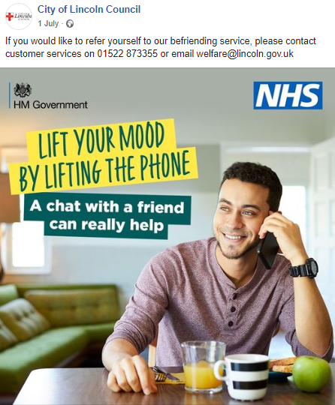

What we wanted to achieve

- A trusted service to support those who are most isolated in our communities
- A service that would provide mutual benefits for our customers and our staff
- Effective working with our signposting service, created to aid and support organisations to deliver vital help to those most in need
From the outset, the team wanted to identify as robustly as possible, those that were suffering most from the impact of losing social connections as well as those who would be less likely to be aware of the available community support. We wanted to design and manage a service, that people could trust wholeheartedly. We wanted a service that would act as that friendly 'over the phone' face, in a time where many people were thrown into an unavoidable lonely and isolated situation. We aspired for the service to also provide an opportunity for staff at the council to be able to make a difference to people's lives. Some of our staff could not carry out their day jobs so this provided a meaningful role that staff could deliver whilst working from home. The irony of our Befriending Service, which looks to alleviate loneliness and isolation with friendly conversations for our residents, is that some of our members of staff live by themselves. We knew from that moment, that it was as much about our staff feeling connected, as it was our residents. With that in mind, we utilised staff who couldn't deliver their usual day to day job due to lockdown in a way where it also helped some of them feel connected. We know from our survey results that this service provided an immensely positive impact, not just in alleviating short-term loneliness whilst the country was in lockdown, but also in character development.

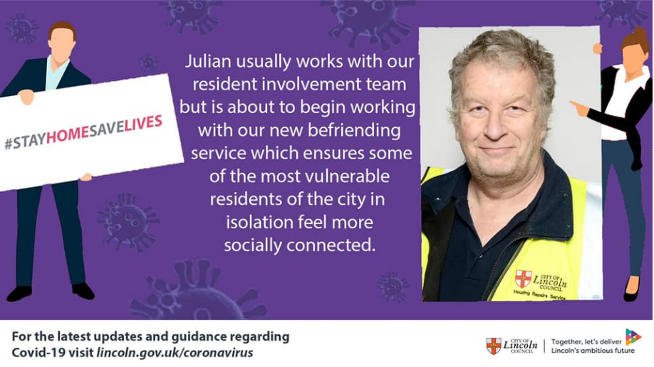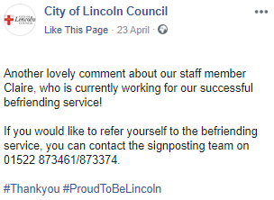

What we achieved

- A peak of over 500 people using the service during May
- 54 befrienders from across the council's workforce deployed to make calls
- Over 18,000 people across the city contacted to see if they wanted calls

While the Befriending Service wasn't about performance or statistics, it would be underplaying its incredible success to ignore the simply amazing facts and figures that came out of its four-month life. By the end of the service, over 18,000 people across the city had been contacted. A feat which took over 3 days of pulling together various registers and lists of residents deemed at risk of loneliness and isolation. The average time spent on the befriending calls made (excluding initial filter calls), was 18 minutes - which is evidence that these calls were not just drop ins, but heartfelt conversations, as we intended them to be from the beginning. 54 members of staff across 10 different service areas, were making calls.
This is an incredible example of true One Council, cross directorate working. Especially considering that this style of work is completely out of the remit of work most of our befrienders usually deal with in their normal day job. In addition to staff members, we also received the support of Ward Councillors who agreed to support the befriending service, again this highlights the passion and desire to support our communities in the city. The complexity of the initial set up included merging thousands of rows of data into one easy to read system to ensure accuracy and robustness, as well as designing a reporting system for our befrienders and large amounts of time being spent on filtering multiple spreadsheets down into one list of possible users.
This success was backed up by over 205 likes relating to the Befriending Service through social media. That's on top of over 15 compliments as a result of befriending calls, 8 compliments as a result of receiving a letter, 7 via social media, 12 general feedback comments. These are in addition to the positive comments received through our surveys and through actual befriending calls
Through receiving contact from our befriending service, we uncovered that many people were lonely and vulnerable, who hadn't previously disclosed this to any support agency, pre COVID-19. Following the Befriending Service approaching them, many felt more comfortable to accept help, and take the opportunity to have support.
We knew that creating a trusted service at this unpredictable time was of paramount importance. We publicised the service widely through social media and radio, as well as providing regular updates through our website and press releases to the media. Provided the Community Signposting service number for people to verify the service. Provided the names of all befrienders to our trusted LinCare service, so residents could check that it was their befriender calling them. We explained where we acquired residents’ details from, so they could verify themselves that their caller was genuine.
Our staff were provided with support to ensure they were comfortable with dealing with what could be potentially complex and emotionally demanding calls. Staff were also kept up to date with the progress of the service including feedback from service users, reflecting the value of the service they were providing. We also shared weekly statistics, which included several measures around how many users were on the service, the average call length and how many people in total that had been contacted. Many staff also commented on their personal development, noting that their ability to listen, understand and not to prejudge had improved.

Who was involved and why it was effective?

Befriending Service Management
The team was pulled together in a slightly different way to usual. A range of officers were asked to temporarily stop their day jobs and attend idea generating sessions within a very concentrated period. The key difference was that other than the overall manager - none of the officers had worked in this field before, but that brought a fresh perspective and importantly the existing skills to make things happen very quickly once the aim was agreed. By having that small but concentrated range of skill sets, the ideas bounced off each other quickly and creatively, to the point where the daily progress meetings boosted the morale because of the way the team was working. This in turn allowed less experienced members of the team, to develop their skills. GDPR and strict security practices were also considered and implemented at every stage, ensuring service users knew where their data had come from and how it was obtained, as well also completing a Health and Safety risk assessment to ensure the safety of our residents and staff. Our communications team strongly engaged with the community throughout, with regular updates to our website, social media and through press releases.

The Befrienders
Due to the nature of the befriending role, it was important that the staff delivering this service were confident and comfortable with potentially upsetting conversations, whilst at the same time being able to keep conversation flowing. As previously mentioned, we also wanted this to be an opportunity for our staff to develop, so we mentored staff who were less confident in the befriending role, in order to help them build their confidence. By doing this, many members of staff by the end of the service's life, were able to pick up emergency calls when other members of staff were unavailable, many were able to refer to third party organisations (where they didn't have the confidence to do so before) and maintain more meaningful conversations with their service users. The cohort of befrienders that were brought together, were a brilliant mixture of people who could talk but also listen. It was ultimately effective because, our befrienders grew to know the people on the end of each and every call, and even when a problem did arise, they had such an extensive background knowledge of our services (as well as the voluntary sector) that most problems could be solved promptly. Where they couldn't be solved easily, befrienders were able to contact a member of staff managing the service at any time for support with difficult situations. As much as realistically and as practically as possible, befrienders and their service users maintained a close one on one relationship, ensuring that the best possible rapport could be built.

The Befriended
We concentrated the focus on known vulnerable residents over 80, then over 70, then over 60 before finally taking the step of mailing out to everyone over 60 to ensure that we hadn't missed anyone. We identified vulnerability through several ways including using our Assisted bin collections list, Housing Benefit recipient list, Council Tax support list, Disabled Facilities Grant list as well as referrals through our Community Signposting Helpline.

Community Signposting Helpline
Alongside the development of our Befriending Service, a small team mobilised themselves to create a community helpline. The helpline provided an independent source to verify the service and signposted where to go to get support in acquiring food and medication deliveries for those who needed it. Staff on the helpline also supported Befriending service staff, and other voluntary sector organisations reach the people who needed the services that they were providing. The helpline facilitated a multi-agency approach, helping to connect customers with the right organisations for their needs. The helpline and befriending service were extremely complimentary of each other, alongside the function of providing advice and guidance, the helpline was the first point of contact for those seeking service. The helpline provided an independent source to verify the service and signposted where to go to get support in acquiring food and medication deliveries for those who needed it. They also supported Befriending Service staff, and other voluntary sector organisations reach the people who needed the services they were providing. The helpline facilitated a multi-agency approach, helping to put service users with the right organisation for their needs.

Our timeline

18th March
A team identified to work on the council's response to supporting communities. The concept of a dedicated helpline and Befriending Service was created

19th March
Daily steering group meetings were convened. We contacted existing services to see if we could add value/agree that further support was required where gaps might exist. We then agreed to set up our Befriending service

20th March
We began to explore how best to reach the most vulnerable residents in our city

23RD MARCH - FULL LOCKDOWN ANNOUNCED

30th March
A process was agreed for staff to follow, including Councillors and those staff who do not have access to IT. We also agreed list of contacts held by the council to make contact with.

2nd April
Letters were sent to our identified potentially vulnerable residents

8th June
Major change to the service as a result of some befrienders being removed due to changes in service demand and the supported housing team coming on board. This involved 1) in advance of 1st June, staff contacting all people on the service to see if they continue to require calls (this was done in 2 days) 2) New befrienders joining the service 3) Significant reallocation of befriendees to fill gaps.

20th July
Our support was less needed as restrictions began to be lifted, staff began to identify if customers would like to continue to receive support and discuss various Befriending options.

31st July
Our council staff cease making calls to their customers. Those customers that wanted to transfer to alternative providers were transferred.

How our staff felt

Both our resident and staff surveys were run for 2 weeks during August. The following results summarise those responses to the surveys. Most responses received were positive and highlight the impact the service had on both staff and residents.

Did you enjoy being a befriender for the City of Lincoln Council?
Out of the 27 respondents, 25 members of staff enjoyed being a befriender. Just 2 members of staff didn't enjoy their time being a befriender. Both of those members of staff had found it difficult to complete the calls as they had competing workload.

Did you feel supported to undertake befriending calls?

Out of the 27 respondents, 25 members of staff felt supported to undertake their befriending calls. Just 2 members of staff didn't feel supported to make their calls.

Do you feel your calls have made a difference to those receiving the service?

Out of the 27 respondents, 26 members of staff felt that their regular calls made a difference to those receiving them. Many staff commented that befrienders felt less lonely and isolated due to their calls. Just 1 member of staff felt that their calls weren't making a difference.

If you referred an individual to the Community Support team for support, was this provided?

Out of the 27 respondents, 20 members of staff felt that when referring one of their users to the Community Support team, the relevant support was provided. From the comments received, support having food and medication delivered was the most requested support.

Have you learned anything from your time on the befriending service that could help you with your 'normal' service work?

Out of the 27 respondents, 14 people felt that they had learnt something that could help with their 'normal' workload, with many commenting an improvement in listening skills as well as being less judgmental. 13 people felt that they hadn't learnt anything that could help them with their 'normal' workload.

Would you like to undertake befriending calls in the future as part of staff volunteering?

Out of the 27 respondents, 15 people indicated that they would take up making befriending calls as part of our Staff Volunteering scheme. 11 people indicated that they would not take up making befriending calls as a volunteer - from the comments, this seems to be mostly because many people have existing volunteering commitments.

How our residents felt

Did you enjoy receiving befriending calls from the City of Lincoln Council?

Out of the 96 respondents, 94 residents enjoyed receiving their regular befriending calls. Many commented that it was refreshing to talk to someone different and felt that the calls were very attentive to their complex needs, such as receiving food deliveries and medication deliveries.
How well did you get on with your befriender?

Out of the 96 respondents, 88 residents got on very well with their befriender. Many commented that they were listened to, not judged and were understood well by our befrienders. Just 8 people said they got on "well" with their befriender. Pleasingly, no one who answered the survey said they didn't get on well with their befriender. This is testament to our kind, warm and genuine staff.
Did the calls help with your wellbeing?

Out of the 93 respondents, 92 residents felt that their wellbeing was either maintained or improved by receiving calls from the Befriending Service. Many felt that their mental health either maintained or improved as a result of having someone to talk to during what for many could have been a lonely and isolated time. 1 resident felt their wellbeing wasn't helped as a result of the calls.

Feedback and compliments

“She also said your calls are really helping her and you are such a lovely lady”

“I rang twice a week and her son rang me today (he’s from Leeds) wanting to thank us for the service that we are providing, and he really appreciates the calls that his mum gets. He said it’s a great service”

“My Goodness!!! I have just done some quality control checks on the calls that are being made and guys we are really making a difference to people’s lives”

“Am continually amazed at the positive reaction the service gets whenever I ring up and speak to people, even those that say they don’t require the service. Everyone has said what a great idea it is, and how it makes them feel connected and valued within the community. My phone calls can range from a three-minute check up on someone, to an hour discussion on anything and everything. I always felt that I wouldn’t be very good doing this sort of thing, but every day I look forward to the phone calls and learning something new about the people I speak to”

“Please do pass on our appreciation to the operative for doing the Safe and Well Check”

“I have to say I as well was really apprehensive about the befriending service when it first started because it was totally out of my comfort zone but I have loved making friendships with some of these ladies. I will really miss them”

“I was talking to a lady this morning, who said CoLC were a credit during the lockdown because they had continued to collect bins, cut grass, etc. throughout the period. She said she’d made a point of going out and thanking the bin men, but also wanted to tell me what a good job everyone has done to keep things going”

“Thanks again for calling my mum, she does appreciate it, and if I can obtain more people to refer, I certainly will”

“Deborah is fantastic, she might think her calls are not doing any good, but she is a massive help to me. I lived through the war as I’m 93 and the war didn’t feel as bad as this, in the war we meet up and had dances and socialised. Now I’m stuck in, but Deborah makes the day a little bit easier for me. She’s Lovely”

“She mentioned during our conversation that her late husband had been in the RAF and was posted to St Mawgan in Cornwall in the 1960s, as was my dad. I mentioned our next door neighbours, the Dugdales (I am still in regular contact with one of the daughters), and she asked if they had a son. Yes I replied, Mark. It turns out he was best friend with her eldest son. We were both quite excited about this, it made my day and hers.”

“Brenda said she really appreciates this and it’s lovely to have somebody to talk to. She feels as though she really knows me. I have had some lovely chats with some lovely people yesterday and today and managed to book them all in again for next week.”

“She wanted us to know the service was brilliant and Jamie a lovely chap.”

“Just completed my first day and I really enjoyed befriending, I’ve done just over 30 calls and now have got 3 people to call up beginning Monday, although it was extremely heart-warming however that many people that did not want the service were extremely keen to share how genuinely wowed by the befriending service and how as a council we work. In addition, it was so positive to hear those good news stories about neighbours checking in on others.”

“Olga was thrilled to have a call and thought the befriended service was a wonderful idea. Olga was very happy to chat, and it was a pleasure talking to her”

“Claire has been a lifeline for me I feel so alone, and she makes me feel better. You people are so lovely and kind.”

“Rachel has been very pleasant and has given me information I didn’t know about, I know where to go if I get stuck, Thank you”

“I must admit it was out of my comfort zone at first but the nice, positive comments I've had at the end of some of the phone calls make it easier. Knowing I might of made a tiny difference at these worrying times is very rewarding.”

“I have to say the people that I have managed to contact have been some of the most cheerful people I have ever spoken to and even where they say they don’t need any help they are very appreciative that someone has called to check”

The future of the service

As restrictions started to ease towards the end of June, we naturally started to see less people requiring our support. As previously mentioned in this report, we were also noticing that many people were lonely and isolated before the outbreak of the pandemic, therefore understanding that closing the service with no contingency plan was simply not an option. With this in mind, conversations were held with third sector partners across the city to see if they had capacity in providing ongoing support to our customers. In addition to our own Lincare service, we were extremely grateful to receive the support of:
- Age UK
- YMCA/Community Lincs
- Assist
Once we were able to identify customers who required ongoing support, our team then discussed the services that these organisations deliver. At the end of our service, there was a total of 79 customers who were transferred over to these providers. Three of our befrienders built up such a strong with rapport with the person they were befriending, that they agreed to continue delivering the service by volunteering for Age UK with those same people.

