De Wint Court,

A Warm Welcome – More about De Wint Court
Choose DeWint Court
A purpose built complex of 50 one and 20 two-bed apartments; De Wint Court is situated on Bowden Drive in the Boultham Moor area of Lincoln for rent.
Here you will enjoy the benefits of renting a home, free from the worries of maintenance or gardening and with like-minded over 55s as your neighbours. Our beautiful apartments have built-in security and lifestyle features that help make the practicalities of day-to-day life easier for you.

Key benefits of De Wint Court are the flexible on-site care and support packages that are built around your needs, a restaurant serving the local community on your doorstep and a hair and beauty salon without going outside the complex.
These stylish, spacious apartments are offered to rent by City of Lincoln Council.

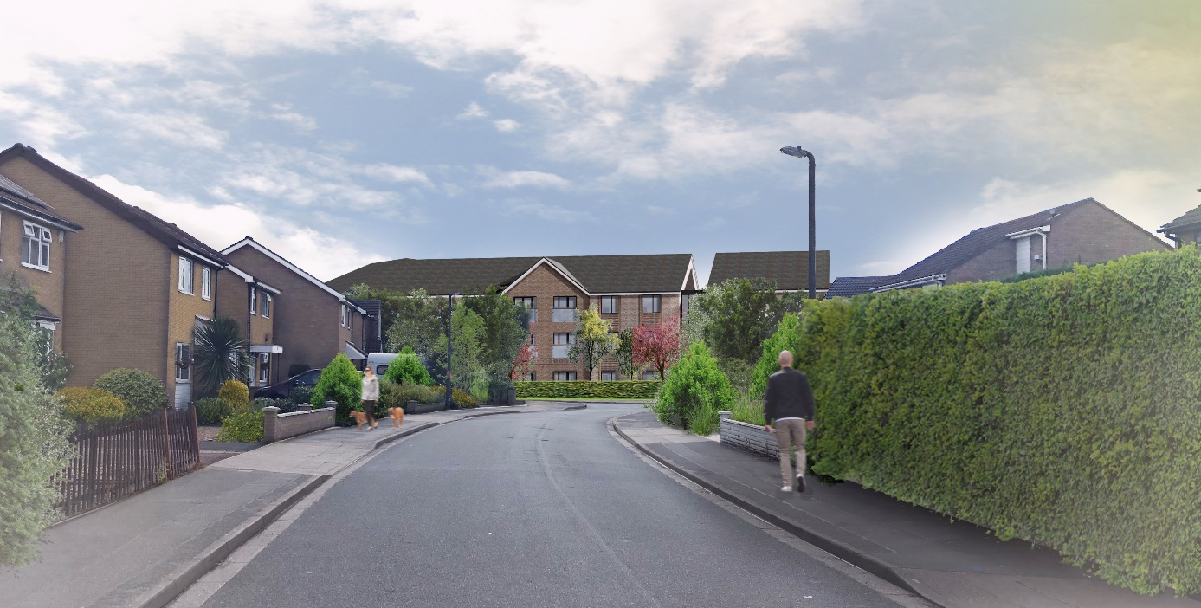
Support
Care and support tailored to your needs
It is reassuring to know that De Wint Court’s care team is on-site 24 hours a day and can provide you with emergency assistance, should you ever need it. If you require support to help you enjoy the independence of your new home, De Wint Court can tailor a package of care to suit your needs. This can be delivered in the comfort of your home by the dedicated team of experts that are fully trained and commissioned by Lincolnshire County Council

You’ll feel right at home at De Wint Court in next to no time. Relax knowing there’s a dedicated Support Manager employed by the City of Lincoln Council on hand during the day from 7.00am – 10.00pm, 7 days a week.
This is a friendly face, who will be around to provide help and support as and when you need it. Our Support Managers don’t just take care of the practicalities of running De Wint Court, they help organise social activities, which our tenants are free to get involved in if they wish. Outside of these hours you can get support offered by City of Lincoln Council’s Lincare Control room who are available at the push of a button 365 days a year 7 days a week.
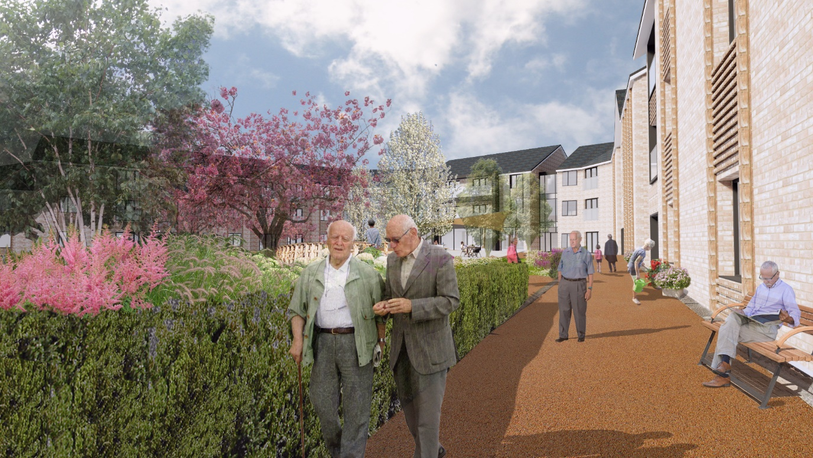

Benefits of De Wint Court
De Wint Court has everything you need to get on with enjoying your retirement to the full.
The stunning social lounge opens out to beautiful landscaped gardens, which we make sure look their best all year round. It’s the perfect outdoor space to sit back, relax and enjoy your retirement with friends, old and new. If you have visiting friends or relatives who would like to stay the night, instead of the hassle of making up a spare bed you can book them into the development’s guest suite, which has en-suite facilities. All you need to do is make the most of their company and introduce them to our fabulous restaurant.
The real benefit of an apartment at De Wint Court is that everything is designed to help you carry on living independently. If you require additional support, now or in the future, there’s a qualified and reliable team right on your doorstep.

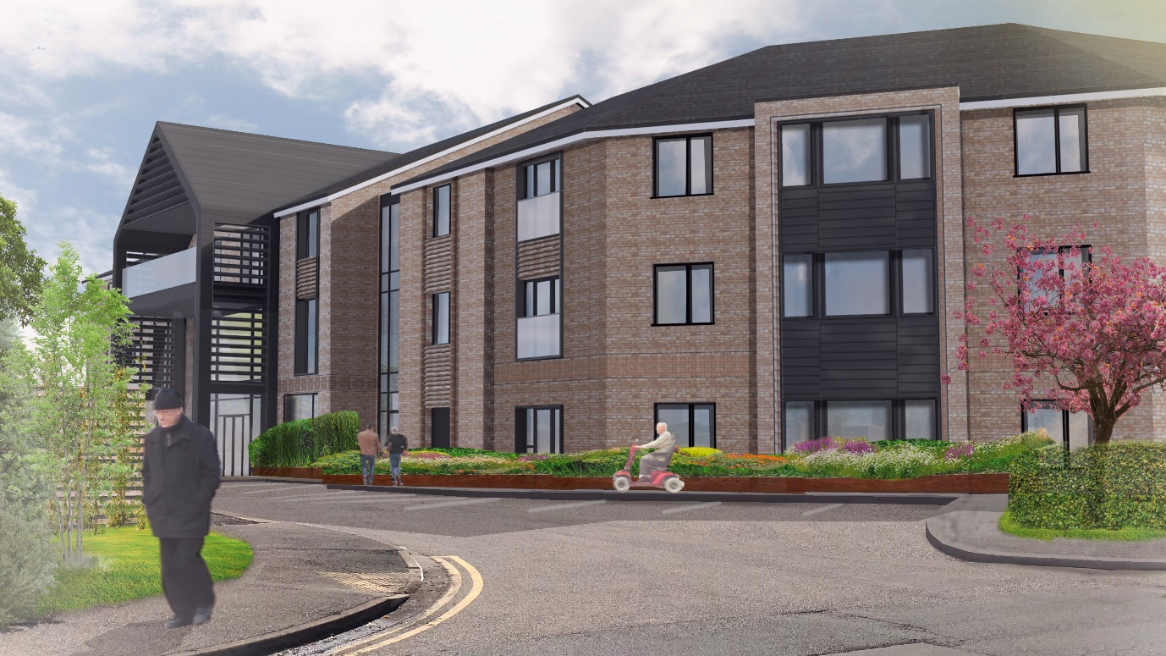

Further benefits

Activities
A range of activities are organised on and off site by our dedicated activities co-ordinator, covering a wide range of hobbies, crafts, games, educational and simply entertaining pastimes for you to get involved in if you so wish.
Let us know if there is anything you and your neighbours are interested in and we will see if we can organise something for you.
Some possible examples:
- Coffee mornings
- Bingo
- University of the 3rd Age classes
- Craft workshops
- Tai Chi Classes
- Games afternoon
- Movement to music
- Shopping trip
- Pat a dog day or other animals
- DeWint Court choir
- Cooking for 1 classes
- Silver surfers club
- Inter-generational work
- Welfare rights clinic
- Gardening Club
- Sunday multi Faith Services
- Budgeting classes
- Memory Classes
- Karaoke evening
- Film Club
- Book Club

In house care and management

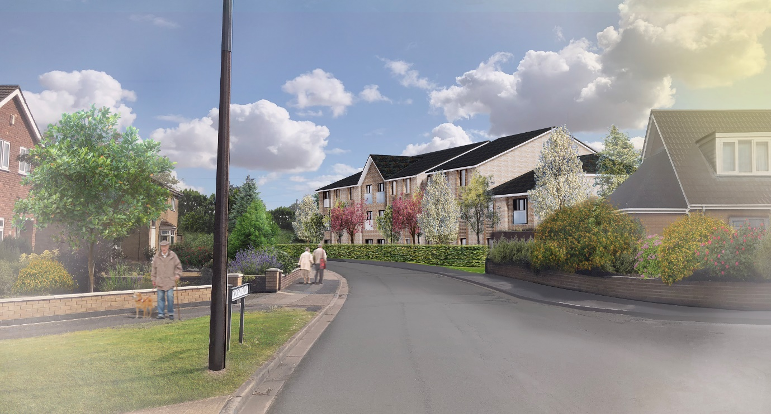

The development
- The social lounge is the perfect place to entertain visitors, socialise with neighbours and make new friends
- Landscaped gardens for you to enjoy, without having to lift a finger
- Guest suite perfect for when friends and family come to visit
- Lift to all Floors
- Bistro restaurant
- Wellness and hairdressing suite
- Car parking
- Mobility scooter store and charging room.
- Changing Places/Baby Change facility
- Assisted bathing with state of the art equipment
Services
- The De Wint Court team - including a dedicated Support Manager and staff on- site from 07:00am – 10:00pm 7 days a week, to provide help and support if required
- On site care team 24/7 commissioned by Lincolnshire County Council
- 24 hour emergency call system, should you need emergency assistance day or night
- You won’t have any worries about the maintenance of the exterior of the property, because all that is taken care of for you
- Cleaners to keep all communal areas spotless

Built to a high Standard

De Wint Court is built to high standards, with double glazing and insulation to be energy efficient and warm. There is also telephone, TV and WiFi available throughout the building.
Consideration has been made to the principals of Sterling and Happi.
Sterling is a design standard for dementia. We’ve:
- Included surfaces and finishes with low reflective values
- Avoided patterned finishes
- Excluded door matting which people with dementia could find prohibitive
- Included kitchen cupboards with vision panels
- Used colour feature walls within the corridors to help with way finding
- Used dementia friendly signage
- Designed the outside space with a continuing path

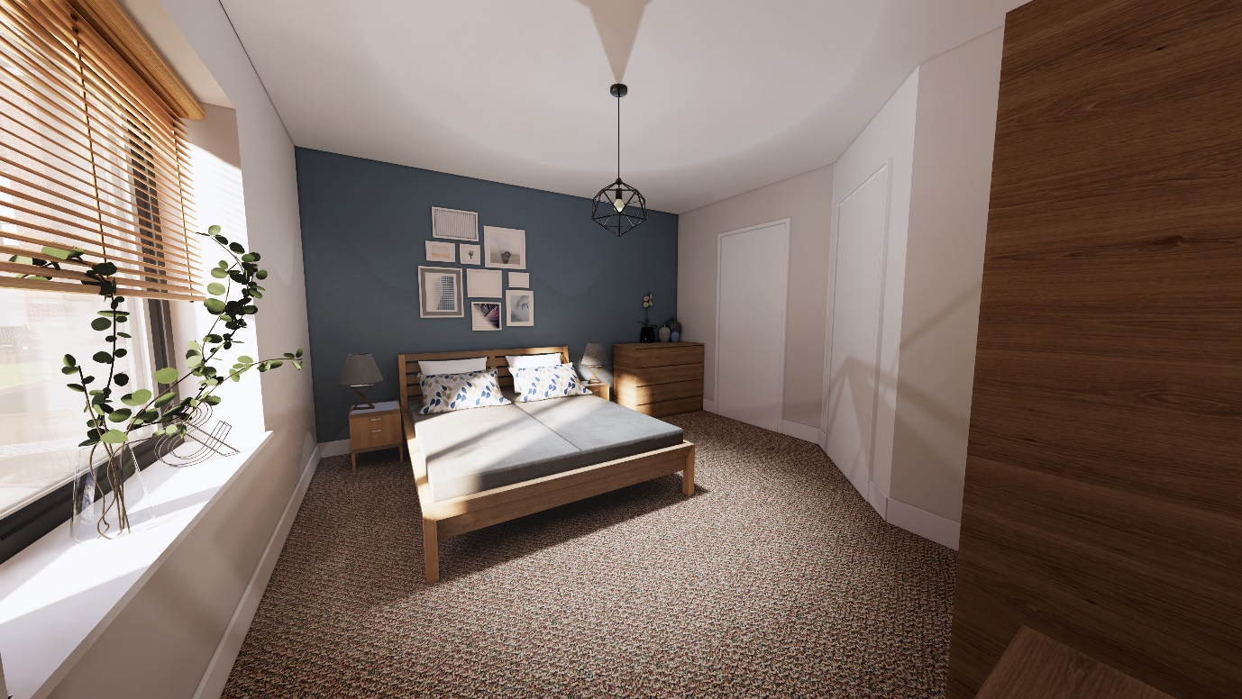
Happi stands for Housing our Ageing Population Panel for Innovation and they outline ten principals of design:
- Space and flexibility
- Daylight in the home and in shared spaces
- Balconies and outdoor space
- Adaptability and ‘care ready’ design
- Positive use of circulation space
- Shared facilities and ‘hubs’
- Plants, trees, and the natural environment
- Energy efficiency and sustainable design
- Storage for belongings and bicycles
- External shared surfaces and ‘home zones’

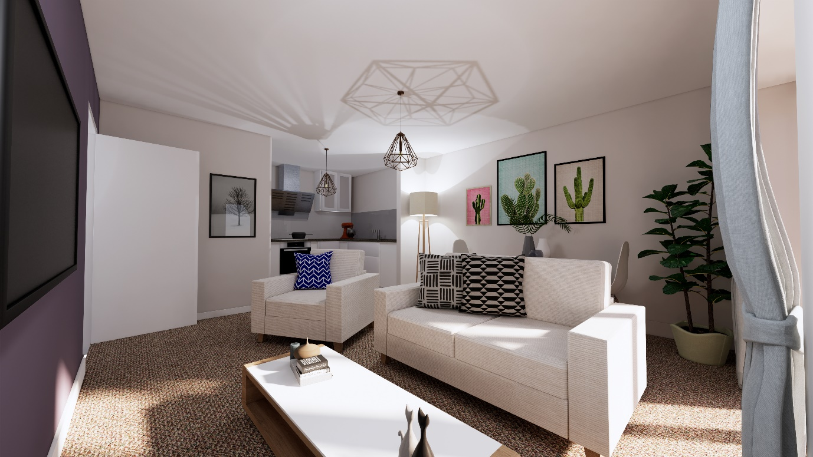

Clever Features
We are confident you will settle quickly into your new home, with plenty of space for your much-loved belongings. When you are visited by loved ones, you can entertain them in the comfort of your home, the main lounge, sensory garden or restaurant.
Selected apartments also benefit from balconies or patio areas.
In the kitchen, you’ll see quality units and finishes with an electric oven and hob and space for you to put a washing machine and fridge freezer.
Our bathrooms are designed to be comfortable, functional and safe with fully fitted level access showers, slip-resistant flooring and lever taps that turn on and off easily. If you fancy a nice soak in a bath, it’s just a short walk along the corridor to the assisted bathroom.
Outside of your apartment, you will find comfortable carpeted corridors with subtle feature walls. large lifts to transport you to the shared communal areas, including the wellbeing suite, lounge, restaurant, salon and gardens.
The lounge will have a library wall, projector and PA system ideal for larger gatherings.
Why not book a salon appointment and follow it with coffee and cake with your neighbours in the restaurant?
The sensory gardens will be a delight throughout the year complete with children’s play area, exercise equipment, raised planters and a gardening club area, water feature and plenty of places to sit in the sunny south-facing gardens.

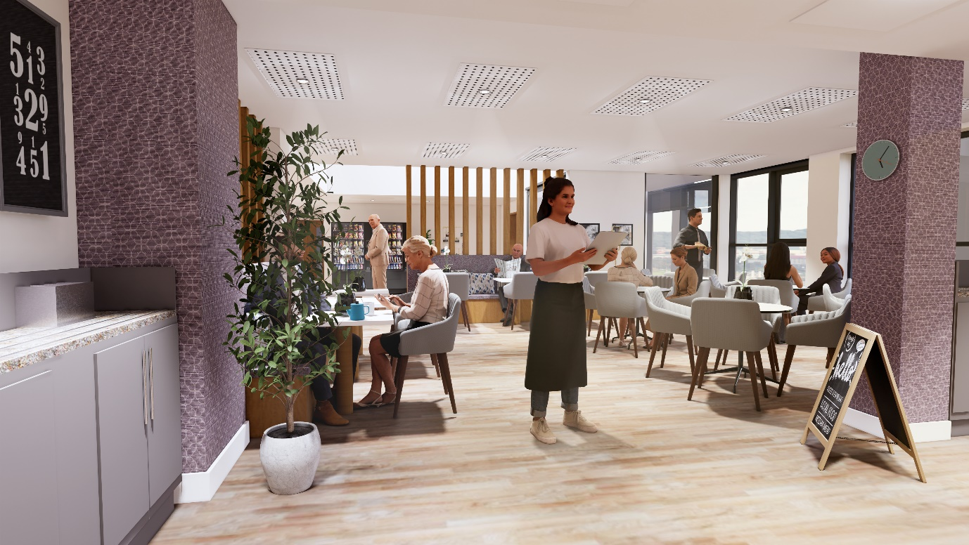

New Apartment in Detail
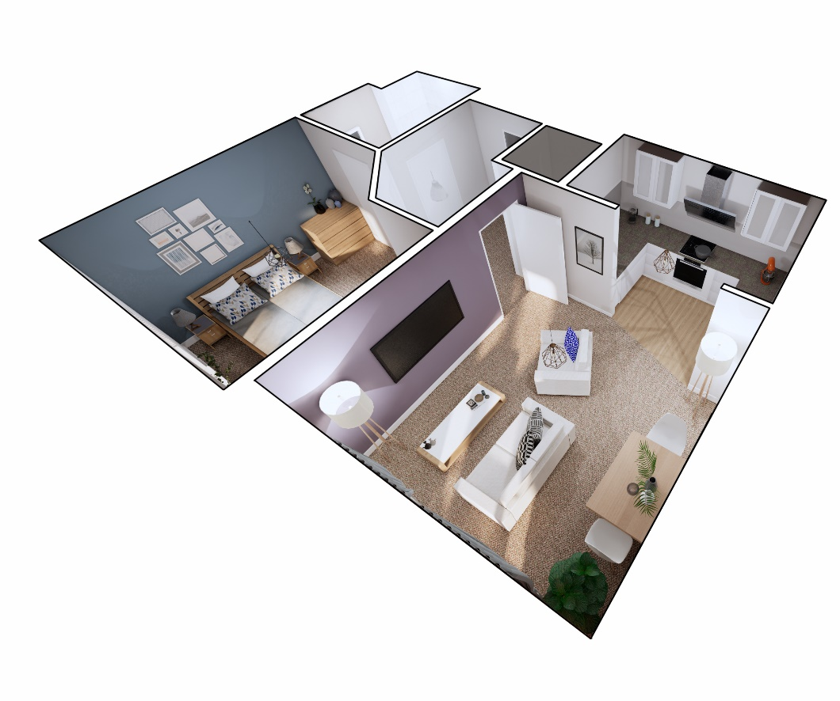
General
- Double glazing to all windows
- Balcony of patio to selected apartments
- Spacious hall storage cupboards
- Telephone and television points
- WiFi
- Warden call system
- Video door entry and handset
- Mobility scooter store
Kitchen
- Fitted kitchen with anti-slip flooring
- Electric oven and hob
- Stainless steel sink
- Lever mixer taps
Bathroom
- Fitted wet room with slip-resistant flooring
- White sanitary ware with high quality fittings
- Shower curtain
- Long shower rail for easy use with a shower seat or stood
Heating and finishes
- Heating from communal boilers, fully customisable within each apartment with the control panel
- Neutral décor
Safety and security
- Door entry system with video
- 24 hour emergency call system with a personal pendant alarm
- Smoke detector linked to the emergency call system and sprinklers
- Management staff on site 7am-10pm, 7 days per week

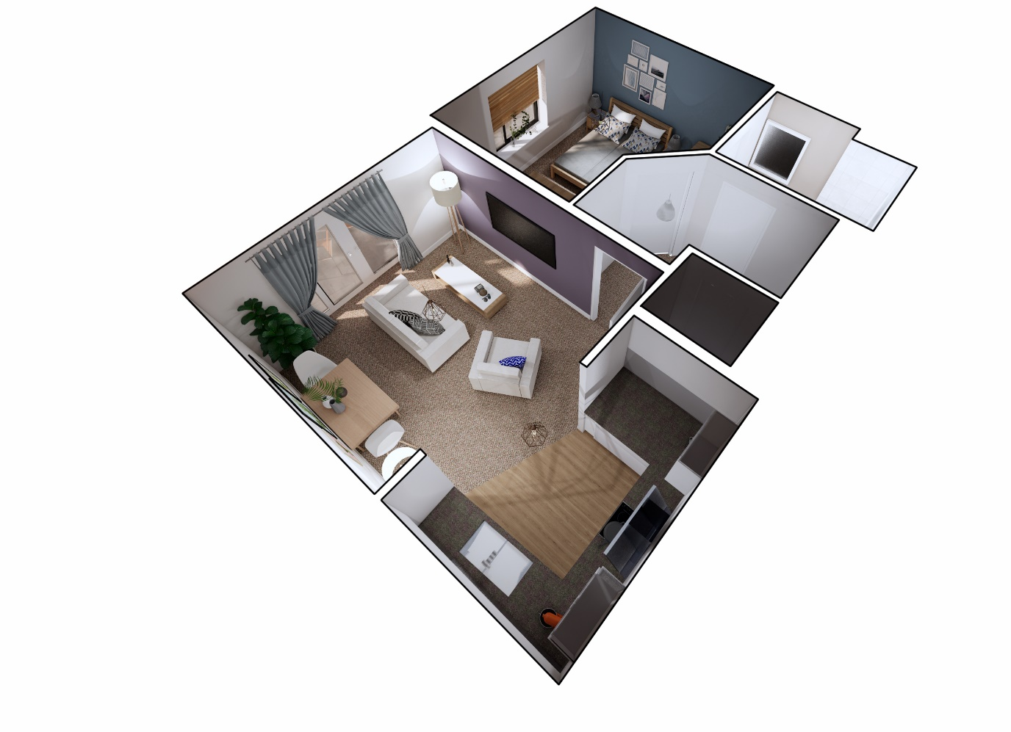

Location
De Wint Court is in a fantastic residential location, close to shops and public transport links.
Hungry Horse pub, Sainsbury’s, Iceland, Matalan, Pound Saver, M&S Foodhall, Elite Fish and Chips, Domino’s Pizza and McDonalds are less than 0.5 miles away on Lindis Retail Park.
A newsagents and other local shops are available on Turner Avenue which is 0.5 miles away.
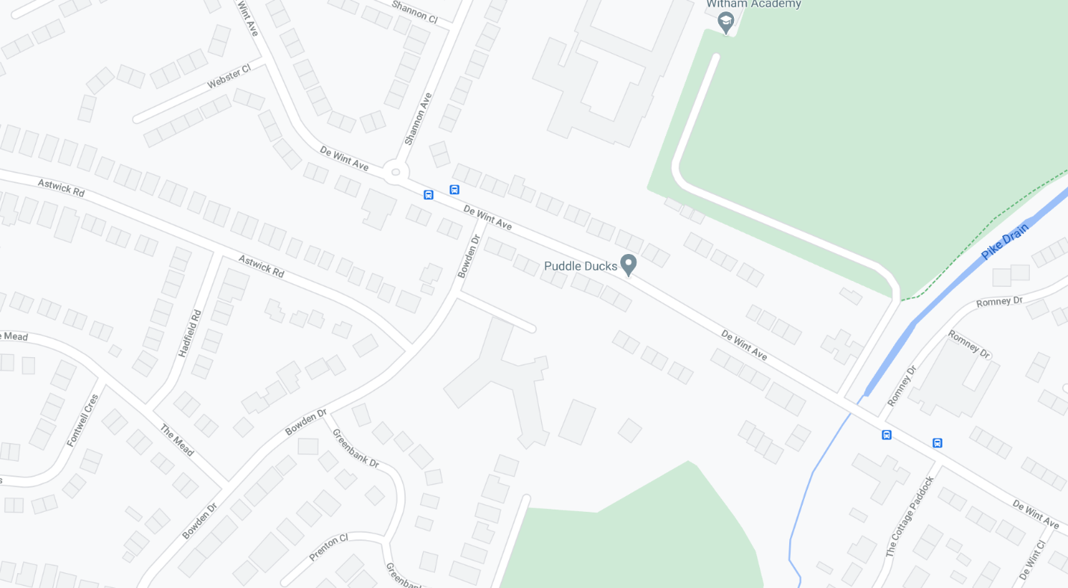
[Map location of De Wint Court, just off De Wint Avenue ]

Interested…? This is how to apply

If you are interested in one of these new flats and you haven’t registered with Lincs Homefinder already, then you will need to visit our website at www.Lincshomefinder.co.uk and register an application for Social Housing. Lincs Homefinder is the City of Lincoln Council’s Housing Register website.

Register an Application.
To do this you will need to go to the Lincs Homefinder website www.lincshomefinder.co.uk, click register (top right of web page). You will initially register a household and then you will need to submit a full application. You do this by clicking on the link that says Apply for Social Housing.
As part of the application you will be asked if you are interested in Warden/Sheltered/Extra care accommodation – you will need to select ‘De Wint Court in Boultham’.

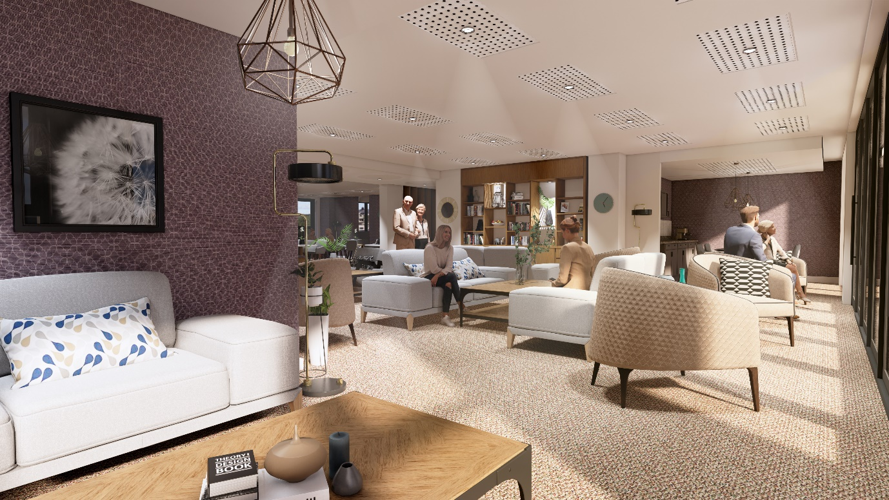

Provide Supporting Documents
Before you click submit for your application, you will be provided with a list of documents that are required to assess your application, you can upload these as part of the online application or you can alternatively email a photo of these to Housingsolutions@lincoln.gov.uk.

Application Assessed
Once your application has been submitted with all required documents, we will assess your application and place you into a band on the housing register. We will notify you of this decision via email.

Interest Recorded
You have now successfully recorded your interest in De Wint Court.

Additional Information
If you are unable to register an application or use the upload facility, then please contact a member of the Housing Solutions Team, who will be able to book an appointment for you to be assisted with registering and provide support and advice on how to supply your documents.
If you are already registered on Lincs Homefinder but not sure if you have registered an interest in De Wint Court, then please login to your application and answer the question as mentioned in the Register an Application section above.

Housing Solutions Team
Email: housingsolutions@lincoln.gov.uk or Telephone: 01522 873777

