City of Lincoln Council

Council Tax Section 13A Relief

Policy and Procedure

Document control

Organisation | City of Lincoln Council
Title | Council Tax – Section 13A Policy
Author - name and title | Tracey Parker – Revenues and Benefits Manager
Owner - name and title | Tracey Parker – Revenues and Benefits Manager
Date | 10 September 2015
Approvals | 17 December 2015 City of Lincoln Policy Scrutiny Committee
Filename
Version | V.02
Next review date | 22nd July 2025

Document Amendment history

Revision | Originator of change | Date of change | Change description
Amended appeal process | Tracey Parker | 29 July 2021 | Amended from Judicial Review to Valuation Tribunal and added contact details for Tribunal.
Housekeeping | Tracey Parker | 29 July 2021 | Tidied up the document. Checked headings and contact details etc. Included the relevant legislation into the document. Included a list of the sort of evidence that would need to be provided with any application. Added ‘use of data’ statement to the application form.
Reviewed | Tracey Parker | 31.8.2023 | No changes made – other than next review date

Distribution and training history

Details | Date

Council Tax – Section 13A Relief
Policy and Procedure

Section 1 Background Information
Introduction and the relevant legislation
Locally

Section 2 Statement of Objectives

Section 3 The Policy
Section 13A Scheme
Eligibility Criteria
Disclosure of Information
Evidence requirements
Decision Making
Payment of an Award
Notification
Right of Appeal

Appendix A Application Form

Section 1

Background Information

Section 13A Relief Background

1.1 Introduction
Section 13A of the Local Government Finance Act 1992 gives the Council a discretionary power to reduce the Council Tax that is payable. We can consider this on a case-by-case basis or to specify a class where several Council Tax Payers may fall into a group due to similar circumstances.

Relevant Legislation

The Local Government Finance Act 1992 , Section 13a covers both the new council tax reduction schemes and the former discretionary power to grant relief

The relevant part of Section 13a reads :

“Reductions by billing authority
- The amount of council tax which a person is liable to pay in respect of any chargeable dwelling and any day (as determined in accordance with sections 10 to 13) –
- In the case of a dwelling situated in the area of a billing authority in England, is to be reduced to the extent, if any, required by the authority’s council tax reduction scheme (see subsection(2)):
- …..
- In any case, may be reduced to such an extent ( or, if the amount has been reduced under paragraph (a) ….., such further extent) as the billing authority for the area in which the dwelling is situation thinks fit.
…..

(6) The power under subsection 1(c.) includes power to reduce an amount to nil

(7) The power under subsection 1(c.) may be exercised in relation to particular cases or by determining a class of case in which liability is reduced to an extent provided by the determination.

1.2 Locally
There is a financial implication to awarding discounts under Section 13A as the District Council must wholly fund any awards granted without any Government support and this therefore has a direct impact on the Taxpayers of the City of Lincoln

Therefore, an award will only be made where it is reasonable for the Council to do so, having regard to the interests of the Council Tax Payers who ultimately fund any discount.

Section 2

Statement of Objectives

City of Lincoln Council recognises that it must be able to respond flexibly to the needs of it’s Taxpayers and that it wishes to support strong and sustainable local communities.

To comply with the Council’s priorities, we need to ensure that we achieve value for money in the delivery of services. We play a key role in addressing issues such as homelessness and health inequalities

Section 13A awards will be used to help mitigate any unforeseen or exceptional hardship circumstances that threaten Taxpayers’ ability to pay the Council Tax or to remain in their homes.

The District Council must wholly fund any award granted under Section 13A without any Government Support. Therefore, any such award must meet certain criteria to ensure they offer value for money to the district’s Taxpayers.

We will –

- Consider each application on it’s own merits

- Be objective

- Balance the interests of our Council Tax Payers who ultimately fund any award

- Deal with any application as timely as possible, which is proportionate to the complexity of the application and the amount of the potential discount.

Section 3

The Policy

3.1 Section 13A Scheme
The Council will consider making a Section 13A award to persons who meet the qualifying criteria, as specified in this policy. All applications will be considered on their individual merits.

Council Tax accounts in joint names must make joint applications for Section 13A Relief.

See application form at Appendix A of this document

3.2 Eligibility Criteria
The Council has the discretion to reduce or remit the Council Tax payable in respect of dwellings in its area, by –

- Persons whom the authority considers to be in financial need, or
- Persons in classes consisting of persons whom the authority consider to be, in general, in financial need.

When determining an application, the following factors will be considered

- There must be evidence of financial hardship or unforeseen, exceptional circumstances to justify any reduction.
- All other eligible discounts must have been explored prior to the application being made.
- Whether the Council Tax Payer/s have access to other funds/assets that could be used to pay the Council Tax
- The historical payment record of the Council Tax Payer.
- The Council must be satisfied that the amount outstanding must not be the result of wilful refusal to pay or culpable neglect.

3.3 Disclosure of Information
Full disclosure of the relevant information is encouraged, and we reserve the right to request evidence in support of your application to assist in the decision making.

We reserve the right to undertake any enquiries we consider necessary which may include verification of the information provided or a home visit.

Any omission or false statement may have a detrimental effect on your application. The Council reserves the right to require the monies to be repaid if at a later date you are found to have made a false claim in order to obtain this discount.

3.3 Evidence Requirements
Evidence required may be determined by the circumstances of the applicant or applicants.

Evidence you may be requested to provide could include –

- A detailed explanation of the circumstances that have given rise to the application.

- An indication of the amount of discount that you are looking for. ( e.g. One instalment, the balance of the current financial year etc)

- A full breakdown of the applicant’s household income and expenditure

- An explanation of the steps already taken to resolve their difficulties to help meet their Council Tax liability.

- A declaration of any substantial assets owned by the applicant/s (property and motor vehicles)

- Bank statements for the last 12 months (or longer)

- Savings accounts

- Letters from your landlord, or mortgage provider, showing that you may lose your home

- If evidence cannot be provided, details of why this cannot be provided.

Whilst any application will be considered on its own merits we will consider the following –

- Should the applicant be in receipt of a statutory discount or exemption?

- Is the applicant experiencing short term difficulties that can be resolved by the rescheduling of instalment payments?

- If not already in receipt of Council Tax support, would the applicant qualify for Council Tax support?

- Have the applicants own actions or inaction been a major contributing factor?

- Is there an alternative enforcement remedy available – such as, could the debt be secured by way of a charging order?

3.4 Application form
Applications should be in writing and provide all relevant supporting information either with your application, or within 28 days of your application.

Failure to provide the evidence as requested may result in your application being refused.

You must use the form in Appendix A.

If the Council Tax account has more than one liable party, the application for the Section 13A must be made by all liable parties and evidence must be supplied in respect of all parties.

The liability for Council Tax is determined by legislation and we are unable to amend the names of the liable parties so that you may make an individual application.

3.5 Decision Making
All decisions will be made by the Revenues and Benefits Manager or the Council Tax Administration Team leader, or by officers of at least equal seniority as and when required.

3.6 Payment of an Award
All awards will be made by crediting the award value to the Council Tax account to which it applies.

The policy allows for payment to the end of the current year as this is a short-term assistance only and should not be considered a way of reducing the Council Tax long term.

3.7 Notification
The Council will aim to notify the applicant or applicants, of the outcome of their request within 5 working days of the date that the decision is made.

Notification will be in writing and will detail –

- The amount of the award, if applicable

- The period of the award, if applicable

- Provide details of how and when the award will be made, if applicable

- The reason or reasons, why your application was unsuccessful, if applicable

- Rights of appeal, if applicable

3.8 Right of Appeal
Section 13A awards are administered under the Local Government Finance Act 1992.

Council Tax appeals reach the Valuation Tribunal under Section 16(1) of the Local Government Finance Act 1992

A person may appeal to a Valuation Tribunal if he is aggrieved by –

- Any decision of the Council the dwelling should be charged council tax, or that he is the person liable to pay the council tax for that dwelling, or
- any calculation made by the Council of the amount which he is liable to pay the Council in respect of Council tax.

Appeals can be made as follows-

Email Appeals@valuationtribunal.gov.uk

Website www.valuationtribunal.gov.uk

Phone 023034458100

3.9 Overpayments
If the Council becomes aware that the information contained in an application for Section 13a relief was incorrect, or that relevant information was not declared either intentionally or otherwise, the Council may seek to recover the value of any award made. The award will be removed from the Council Tax account and the balance will be subject to the normal recovery methods for Council Tax.
3.9 Fraud
The Council lis committed to the fight against fraud in all its forms. Any applicant who fraudulently attempts to claim a Section 13a relief may have committed an offence under the Fraud Act 2006 and this matter will be investigated and dealt with appropriately. This may lead to criminal proceedings.

Section 4
Monitoring

The Council is committed to its responsibility to equality and fairness and will ensure that people are treated fairly and given fair chances. The scheme aims to give the fairest outcomes to everyone regardless of race, gender reassignment, age, disability, religious beliefs, sex or sexual orientation.
This policy will be monitored and reviewed to ensure it has been applied fairly and consistently

For further information please contact the Council Tax Section on 01522 873355

Other Languages

All written communication will be available in alternative languages, large print or braille where identified or on request.

If you have difficulty in understanding anything in this document, please go to the Council Offices, where we can call in an interpreter for you through the National Interpreting Service.

City of Lincoln
City Hall
Beaumont Fee
Lincoln
LN1 1DD

FRENCH

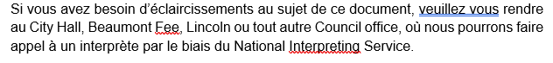

POLISH

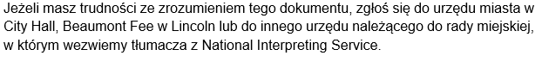

PORTUGUESE

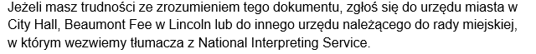

TURKISH

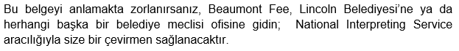

BENGALI
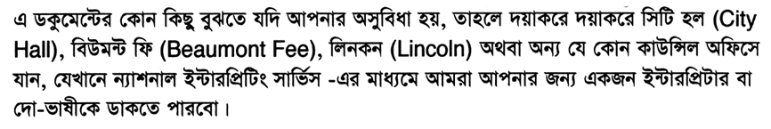

FARSI

SORANI

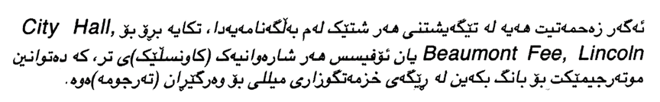

KURDISH

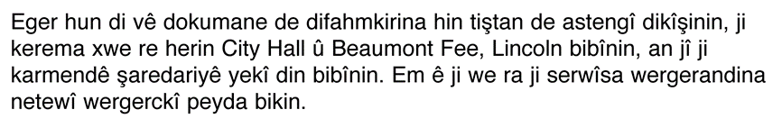

RUSSIAN

CZECH

SLOVAK

LATVIAN

LITHUANIAN

Appendix A

APPLICATION FOR COUNCIL TAX REDUCTION UNDER SECTION 13A
OF THE LOCAL GOVERNMENT FINANCE ACT 1992

Please note that if a joint bill has been issued then the application must be made in joint names.

Name of Applicant 1 | Contact Details of Applicant 1
Name of Applicant 2 if applicable | Contact Details of Applicant 2 if applicable
Address of property | Council Tax account number
Do you live in this property as your sole or main residence?  Applicant 1 Yes / No  Applicant 2 Yes / No / Not applicable | If this is not your sole or main residence – is the property empty?
Is the property currently up for sale?  Yes / No | Please provide details of the agent dealing with the sale, if applicable
Is the property currently marketed for rent?  Yes / No | Please provide details of the agent dealing with the rental, if applicable

Please provide details of any other properties or land owned by you and the value of any rental income that you receive from these properties or land - please continue on separate sheet if you need to.

If you have left a property empty to move to more suitable accommodation or to receive or provide care due to old age, disablement, illness, alcohol or drug misuse or mental disorder please provide the details below

Please provide detailed reasons why you are applying for a reduction in your Council Tax. This should fully explain the circumstances that are creating financial difficulty and how long you expect these circumstances to continue – please continue on a separate sheet if you need to.

Have you previously made an application for Council Tax Reduction?

Yes / No

Are you receiving financial assistance from any other source?

Yes / No If yes, please provide details

Have you approached any organisations to help you with your current financial situation – this may include Citizens’ Advice, or Money Advice – please provide details

Please provide details of any stocks/ shares / savings that you have, or any money that you are owed

Please provide any additional information that you may wish to provide in support of your application

Your application will not be processed unless the information above and
the enclosed financial information sheet is completed and returned.

All applicants must provide documentary evidence in support of their claim. At a minimum these should include the following,

- Confirmation of all income received
- Bank statements for 12 months
- Any additional informaion to support the application
- Written details of any savings/stocks and shares.

These must be provided for ALL persons named on the Council Tax account, further documents may be requested if the Council is not satisfied that there is sufficient evidence of hardship.

I declare that the information I have given on this form is complete and accurate, to the best of my knowledge.

I also understand that whilst this application for relief is pending I am not entitled to withhold payment of the Council Tax due to the Council.

Signature 1 Date

Signature 2 Date

Data Matching – This authority is under a duty to protect the public funds it administers, and to this end may use the information you have provide for the prevention and detection of fraud. We may also share this information with other bodies responsible for auditing or administering public funds for theses purposes as well as oter organisations including private sector companies if the law allows this. Please see our website www.lincoln.gov.uk for our full Data Protection statement.
Income and Expenditure - must be provided with your application form

WEEKLY INCOME |  | £ | CAPITAL (savings/Assets) | £
Your Net wages including overtime and/or commission |  |  | Post office account(s)
 |  |  | Bank Account(s)
Net wages of Partner |  |  | Building Society Account(s)
JSA/Income Support |  |  | National Savings
Working Tax Credit |  |  | Premium Bonds
Child Tax Credit |  |  | Cash Savings
Incapacity Benefit |  |  | Stocks and Shares
Guaranteed Credits |  |  | ISA(s)/PEP(s)
Savings Credits |  |  | Any other assets (Please detail)
Occupational Pension
Private Pension/Annuity |  |  | TOTAL SAVINGS/ASSETS
State Retirement Pension
Child Benefit |  |  | Any interest in ANY property other than your present home in this country or abroad
Charitable Voluntary Payments from relatives/Friends/any other source
Income from boarders and lodgers |  |  | Any other income/capital (Please specify)
Maintenance received
Disability Living  Allowance | Care
 | Mobility
Carers Allowance
TOTAL INCOME

WEEKLY EXPENDITURE | £ | TV Licence
Rent / Mortgage  Including repayment of arrears |  | Cable / Satellite TV
 |  | Clothes
Ground Rent/Service Charge |  | Baby Essentials
Council Tax |  | Child Support Payments
Food/Housekeeping |  | Maintenance Payments
Water Charges |  | CCJ’s
Gas |  | Fines to a court
Electricity |  | Other fines (please detail)
Telephone – Landline / Internet |  | Loan/Credit Repayments
Telephone - Mobile |  | Credit Card
House Insurance |  | Hire purchase Repayments
Personal Insurance |  | Mail Order Payments / Catalogues
Child Care Fees |  | Regular Prescription charges
Social and Leisure |  | Cigarettes / Tobacco
Car Tax |  | Any other expenditure (Please detail)
Car petrol costs
Car Insurance
Car Maintenance
Travel Expenses (Public Transport)
 |  | TOTAL EXPENDITURE
Signed _________________________________________Date________________________

