Carholme Neighbourhood Plan
Publication of Neighbourhood Forum Designation and Neighbourhood Plan Area

Consultation Statement

October 2026

Introduction

The purpose of this document

This document provides a record of the publication that took place regarding the Carholme Neighbourhood Plan Forum and related Neighbourhood Plan Area. The main methods used to promote the publication process are also documented along with the main findings from the publication. As this was a publication process and not a more open consultation, the response rate is not expected to be high.

This formal publication period provided members of the public and other key stakeholders an opportunity to submit comments on the proposed neighbourhood plan area and proposed neighbourhood body for Carholme. The proposed neighbourhood planning body is the Carholme Neighbourhood Plan Project Group (CNPPG) and the proposed neighbourhood planning area is shown in Appendix 1 along with the CNPPG application. Appendix 2 contains details of the designation approval.

Regulations and Government Guidance

The regulations associated with this first stage of neighbourhood planning provide guidance on the criteria to be included for this phase. Within this publication, we as the Local Planning Authority must publicise on our website:

A copy of the area application;

Details on how to make representations; and

The date by which those representations must be received, being

In the case of an application to which paragraph (2)(b) of Regulation 6A applies, not less than 4 weeks from the date on which the area application is first published;

In all other cases, not less than 6 weeks from the date on which the area application is first published

Publication Timescales

The publication period for this stage of the neighbourhood plan process must cover a minimum period of for weeks. The proposed publication period is from 30 April-11 June 2025.

Publication Responses

We received 0 responses to the consultation. This is generally in keeping with the response rates for this early stage of the neighbourhood planning process.

Outcomes

The results of this publication will be used by the City of Lincoln Council to decide whether or not to approve the Carholme Neighbourhood Plan Area and body for the neighbourhood planning process to be undertaken by CNPPG.

The City of Lincoln Council has approved the application by the CNPPG to be designated as a neighbourhood forum and have the Carholme Neighbourhood Plan area (see Appendix 1) designated as a neighbourhood area for the purposes of producing a neighbourhood plan (see Appendix 2).

Appendix 1
City of Lincoln Council
City Hall Lincoln
Beaumont Fee
LN1 1ED

11th April 2025

Sent on behalf of Carholme Neighbourhood Plan Project Group (CNPPG)

Dear XXX,

I am writing to apply for CNPPG to be designated as a Neighbourhood Forum and provide the relevant details below. The name of the proposed neighbourhood forum is: Carholme Neighbourhood Forum

The written constitution for CNF is attached.

The name of the proposed neighbourhood area to which this application relates is:

Carholme Neighbourhood Area (CNA). A map which identifies the area is included at the foot of this letter. The area map also appears in the attached constitution.

Contact details for the proposed Neighbourhood Forum are:

XXX
CNPPG Secretary
XXXXX
Lincoln
XXXX

The CNPPG believes it meets the requirements of the three legal tests to be designated as a Neighbourhood Forum and this evidence is presented below.

- Test 1: Promoting or improving the environmental, economic and social wellbeing of the area
The aims of the CNF, as expressed in the proposed CNF constitution, include “Promote and improve the social, economic and environmental well-being of the
Carholme Neighbourhood Area.” (Section 2.1a of the constitution)

- Test 2: Having membership open to all those who live, work and carry out business within the area as well as elected members CNF membership is open to all the above categories:
  - “Membership of the Forum shall be open to all residents living in the area, all those who work or carry out business in the area, and elected members for the area.” (Section 8.1 of the constitution).
  - “All applications for membership shall be made in writing to the Secretary of the Neighbourhood Forum.” (Section 8.2 of the constitution).

- Test 3: Membership includes a minimum of 21 people who either live, work or carry out business within the neighbourhood area as well as elected members

On 21st November 2024 at a Special meeting of the Carholme Community Forum in relation to the Neighbourhood Plan project, it was confirmed and minuted that more than 21 people had put forward their names in support of a neighbourhood plan.

Following Steps
Subject to being granted Neighbourhood Forum designation, CNF plan to set up a working group to lead the development of the plan. This group will include a local councillor and a business representative.

The working group would be tasked with ensuring engagement with other interested parties and for applying for grants to pay for specialist support for the development of the neighbourhood plan. The group’s activities would be overviewed by the CNF committee.

Depending on the time to achieve designation (with its 6-week consultation period) and the speed with which grants can be obtained we would ideally want to start the wider consultation process with the community in early summer.
.
I trust that this information will enable City of Lincoln council to designate CNPPG as a Neighbourhood Forum for the Carholme area.

I look forward to hearing from you.

Kind regards,
CNPPG Secretary

Attached
- CNF constitution
- Minutes of a Special meeting of the Carholme Community Forum, 21st November 2024

CNF Neighbourhood Plan Area

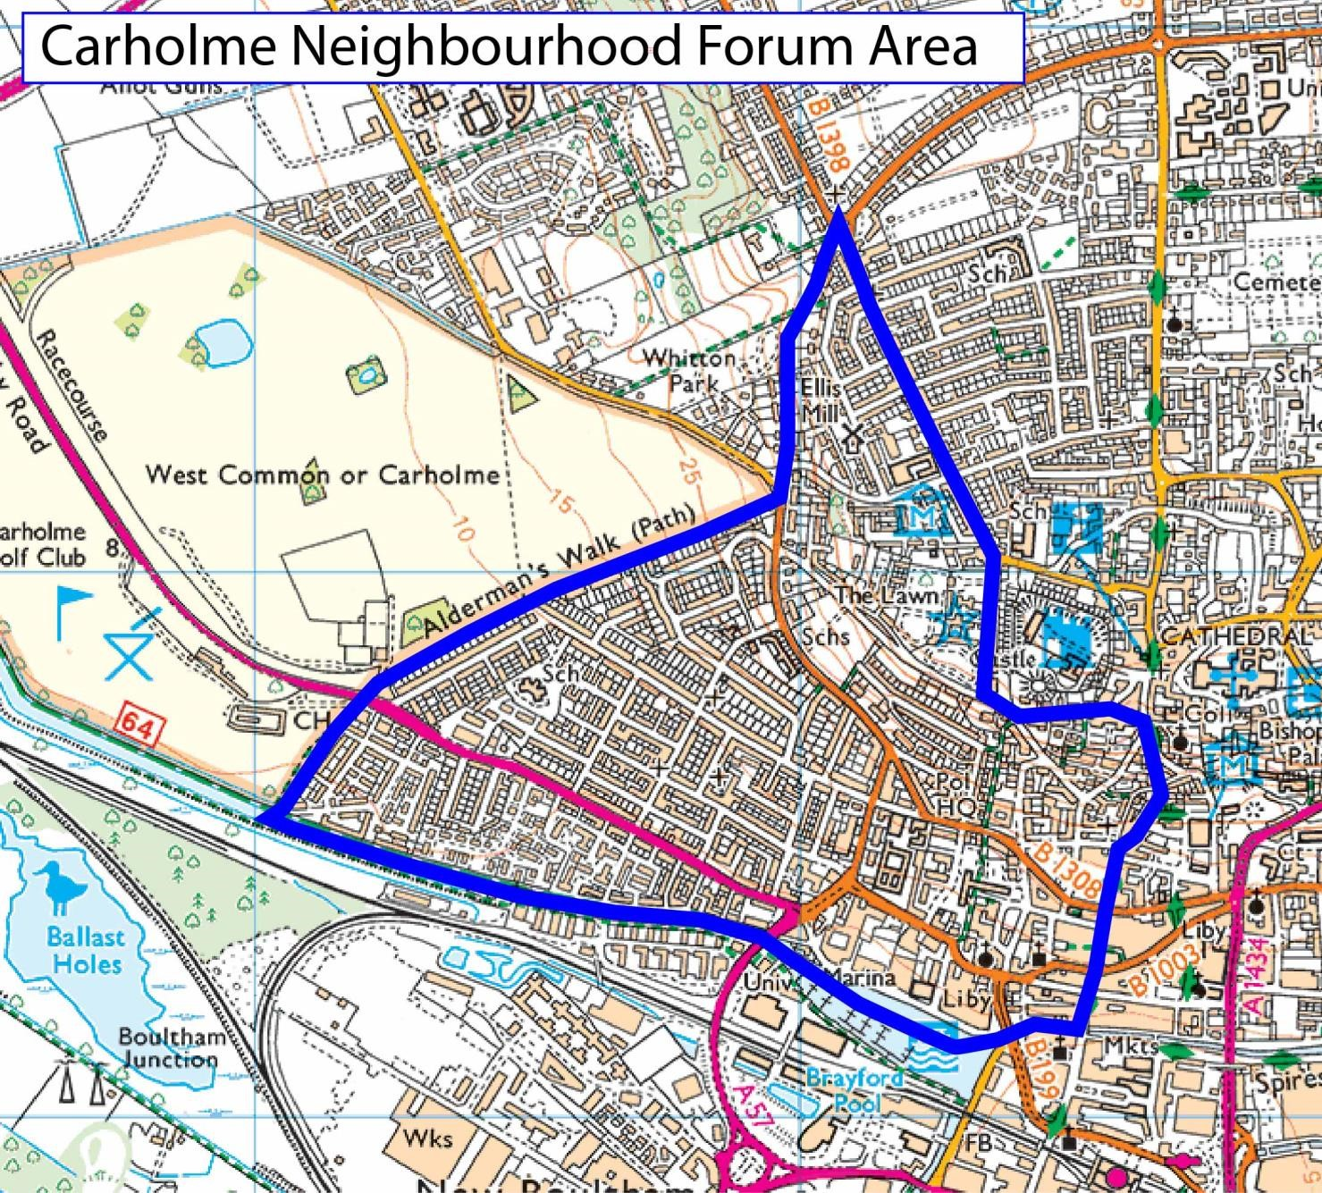

Appendix 2


Directorate of Communities & Environment
Simon Walters MBA, ACIS, MCMI
City Hall, Beaumont Fee,
Lincoln. LN1 1DD
Telephone: (01522) 881188
Facsimile: (01522) 567934
Website: www.lincoln.gov.uk
Minicom: (01522) 873693 - Reception

Toby Forbes Turner
is dealing with this matter
E-mail: toby.forbes-turner@lincoln.gov.uk
Direct Line: (01522) 873804

13th June 2025

XXX
CNPPG Secretary
XXX
Lincoln
XXX

Dear XXX

CARHOLME NEIGHBOURHOOD PLAN PROJECT GROUP(CNPPG):NEIGHBOURHOOD FORUM DESIGNATION

I refer to your application made to the City of Lincoln Council dated 11th April 2025 for the CNPPG to be designated as a Neighbourhood Forum.
Following the statutory 4-week public consultation period where no objections and/or other applications have been received and having assessed your application against the three legal tests as required under the Neighbourhood Planning Regulations 2012, I am pleased to announce that CNPPG have been designated as the Neighbourhood Forum.
I am also pleased to announce that the CNPPG Area has been approved as submitted in your application letter.

On behalf of the City of Lincoln Council, I wish you every success in developing the Neighbourhood Plan and I look forward to providing support and assistance where I can.
Yours sincerely
Toby Forbes Turner
Planning Policy Manager MRTPI

Regulation 6, Town and Country Planning, England-The Neighbourhood Planning (General) Regulations, April 2012 (Amended)

