

DEPARTMENT OF HOUSING AND INVESTMENT

REMEDIES POLICY

Document Control
Organisation | City of Lincoln council
Title | DHI Remedies Policy v1.1
Author | Paula Burton
Owner | DHI
Review date | October 2027

Revision History

Revision Date | Author | Previous Version | Description of Revision
October 2026 | Corporate Complaints Officer | 1.0 | Updated values in Appendix following Housing Ombudsman guidelines, updated wording for Insurance and Disrepair process following internal consultation.
March 2024 | Paula Burton

Document Approvals

This document requires the following approvals:
Sponsor Approval | Name | Date
CMT | Joanne Crookes | 22 October 2024
Housing Scrutiny Sub-Committee | Emily Holmes | 31 October 2024
Policy Scrutiny Committee | Joanne Crookes | 19 November 2024
Executive | Joanne Crookes | 18 November 2024

Table of Contents

1 | Purpose | 4
2 | Key Principles and Service Standards | 4
3 | Equalities Statement | 4
4 | Policy Detail | 5
4.1 | Right to Compensation for Improvements | 5
4.2 | Disturbance Allowance/ loss of utilities | 6
4.3 | Gesture of Goodwill | 7
4.4 | Payment of Compensation to Customers | 7
4.5 | Review of Decisions | 7
4.6 | Disputes | 8
4.7 | Insurance Claims | 8
4.8 | Housing Disrepair Claims | 8
Appendices
Appendix A | Qualifying improvements | 10
Appendix B | Rent refund for disturbance allowance | 11
Appendix C | Disturbance Allowance Claim Form | 12
Appendix D | Gesture of goodwill matrix | 13

DHI REMEDIES POLICY

1. | Purpose
1.1 | We recognise that occasions do arise when we may make a payment in recognition of loss or detriment suffered, in the form of compensation to a customer who has an interest in a property owned and/or managed by the City of Lincoln Council under the terms of a tenancy or lease agreement
1.2 | This policy also details who is entitled to make a claim for compensation and how the amount of compensation awarded will be determined.
1.3 | This policy does not cover payments to settle claims for personal injury. These are dealt with separately by our insurers.
1.4 | This policy does not cover the provision to financially compensate for reasonable expenses incurred when a tenant is temporarily decanted to another property whilst their home received major repair works, refurbishment, or undergoing remedial work; this will be set out within the City Councils’ Decanting Policy.
1.5 | This policy is intended to provide general guidance only. Each individual claim for compensation will be considered on its merits against the statutory and policy framework.
1.6 | This policy should be read in conjunction with the City of Lincoln Council’s Corporate Complaints Policy which may be used by customers who feel they have experienced a service failure.
2. | Key Principals and Service Standards
2.1 | We are committed to achieving the highest possible standards in the services we provide. This policy will ensure that a consistent and fair approach to compensation, gestures of goodwill and ex-gratia payments is taken by:  - Ensuring that tenants and leaseholders are not materially disadvantaged as a result of asset management, repairs or service failures.  - Applying this policy effectively and proportionately.
3. | Equalities Statement
3.1 | We will ensure that this policy is applied fairly and consistently to customers. The council will not directly or indirectly discriminate against any person or groups of people because of their age, disability, gender, gender reassignment, marital or maternity status, race, religion or sexual orientation.
3.2 | When applying this policy, we will act sensitively towards the diverse needs of individuals and communities.
4 | Policy Detail
4.1 | Right to Compensation for Improvements
4.1.1 | Secure tenants with the City of Lincoln Council are entitled to compensation for certain improvements they have made, following a move from their property, they may be entitled to compensation if:  - They have carried out qualifying improvements to their property;  - They have obtained the written consent of the City of Lincoln Council; and  - The cost of an improvement is £50 or more; and  - The works were started after 1 April 1994.
4.1.2 | A qualifying improvement is one that is listed in the table details in Appendix A.
4.1.3 | The maximum compensation that can be paid for any single improvement is £3000.
4.1.4 | To make a claim the tenant must write to the council, within the period starting 28 days before, and ending 14 days after the tenancy end date and provide the following information:  - Name and address, including a forwarding address.  - Details of the improvements made.  - How much each improvement cost, together with the invoices and receipts.  - The date the improvements began and finished.  - Copies of all relevant certificates to demonstrate that the improvement met with the required legislation and building control standards, where relevant.
4.1.5 | Our contact details are as follows:  - Email: customer.services@lincoln.gov.uk  - Call: 01522 873333 (Housing)  - Write to: City of Lincoln Council,  City Hall,  Beaumont Fee,  Lincoln,  LN1 1DE
4.1.6 | We will inspect the improvement and information provided to ensure that the works have been completed to an acceptable standard before considering whether to make an offer of compensation. If works fail to meet this standard, or relevant safety certificates are not provided, no compensation will be offered, and the customer may be asked to re-instate the property to its original condition at their own expense or pay for the damage to be rectified if the work is not completed.
4.1.7 | We will consider the following factors when determining the level of compensation:  - The cost of the improvement.  - The time since the improvement was completed; and  - The notional lifespan of the improvement.
4.1.8 | The level of the compensation payable may be reduced or increased if:  - The cost of the improvement was excessive  - The improvement is of higher / lower quality than it would have been had the landlord completed the works.  - The improvement has deteriorated at a greater/lesser rate than the expected notional life, as detailed in Appendix A, for normal wear and tear.  - If the improvement was funded by a grant.
4.1.9 | Tenants will not be entitled to claim compensation if they have assigned their tenancy to someone else, purchased the property under the Right to Buy scheme, moved through a Mutual Exchange, or if the tenancy was ended by way of a court order. In addition, the City of Lincoln Council may refuse claims for compensation if the improvements were not authorised.
4.2 | Disturbance Allowance
4.2.1 | We undertake many improvement programmes during each year and recognise that these may disrupt tenants. To compensate for this disruption, we have introduced a Disturbance Allowance payment scheme. This applies only to works done as part of an improvement programme and not repairs a tenant has asked for.
4.2.2 | We will grant a decoration voucher to compensate for any damage to decoration.
4.2.3 | The Disturbance Allowance is calculated as a percentage of weekly rent charges, refunded either as a rent credit if you are in arrears, or BACS payment into a bank account.
4.2.4 | You may qualify for a Disturbance Allowance if:  - You lose the use of part of your home for more than one week.  - You are not rehoused during the works.  - You lose the use of part of your garden for more than one week.  - You have scaffolding up for longer than 4 weeks.  See further details on how we define these terms in the section below.
4.2.5 | Losing the use of part of your home means you are unable to use a room or amenity because building work is going on during the day, or you are unable to use a room or amenity outside normal working hours because of the type of work being done. See Appendix B for details.
4.2.6 | Losing the use of part of your garden means you may be entitled to compensation if the council or our contactor uses either your front or back garden to store materials. The allowance would be 20% of the weekly property rent for each full week of loss. If both the front and back gardens are used, the allowance will be 50% of the weekly rent for each full week of loss (part weeks do not count).
4.2.7 | Having scaffolding up for more than 4 weeks means you may be entitled to compensation. The allowance would be 20% of the weekly property rent for either the front or back walls of your property. If both the front and back of the property have scaffolding up for longer than 4 weeks, the allowance would be 50% of the weekly property rent (part weeks do not count).
4.2.8 | To claim please use the disturbance allowance claim form at Appendix C or write to the City of Lincoln Council.
4.3 | Gesture of Goodwill
4.3.1 | We may consider making a payment as a gesture of goodwill where service delivery failings cause exceptional inconvenience, stress, disturbance or annoyance.
4.3.2 | Any requests for compensation as a result of a service delivery failure will be investigated and payment may be offered in line with our goodwill payment matrix. See Appendix D.
4.4 | Payment of Compensation to Customers
4.4.1 | Any offer of compensation will be made on a without prejudice basis. The customer will be invited to confirm acceptance of the payment in writing.
4.4.2 | We reserve the right to use flexibility when applying this policy and will deal with requests on a case by case basis. It may be appropriate to remedy a complaint with actions separately from, or in conjunction with, an offer of compensation. These can include the following:  - Non-financial remedies (such as offering to undertake repairs or redecoration which would otherwise be a customers responsibility)  - Decoration vouchers
4.4.3 | Compensation payments to customers will be offset against any housing debts owed to the council, including rent arrears, or re-charges for rectification of damage. Following the offset, any balance remaining will be paid directly to the customer via BACS transfer.
4.5 | Review of Decisions
4.5.1 | Customers can appeal against a decision not to award compensation, or the level of compensation awarded, and can request that the decision is reviewed within 14 days of the decision being made. The decision will be reviewed by a more senior Manager who was not involved in the original decision.
4.6 | Disputes
4.6.1 | If a customer remains dissatisfied with the offer the case can be considered through the Corporate Complaints Policy.
4.6.2 | In the event that the Council is unable to resolve matters of dispute through our internal processes, the case can be referred to the Housing Ombudsman Service.
4.7 | Insurance Claims
4.7.1 | There is a separate process for dealing with claims for personal injury or damage to property which fall under the Council’s public liability insurance policy.  If a customer alleges negligence in some way, the City of Lincoln Council reserves the right to refer any claim to its solicitors or insurers for investigation. Examples of this may include (but are not limited to) where:  • The customer suggests that they, or a member of the household, have suffered a personal injury as a result of something the council, or its agents/contractors, have done or not done.  • Damage to personal belongings (excluding damage to interior décor as a result of a routine repair).
4.7.2 | Tenants and leaseholders are expected to take out contents insurance, for which there are numerous insurance providers who offer low-cost schemes. This policy is not intended to compensate for a customer’s lack of contents insurance.
d
4.8 | Housing Disrepair Claims
4.8.1 | In an instance where we have been notified of a need for repair to one of our residential dwellings or blocks of flats, but have failed to rectify the problem, a customer may wish to make a claim against the City of Lincoln Council for disrepair. This includes claims for damp and/or mould being present in a property.
4.8.2 | We urge anyone who feels they might have such a claim against City of Lincoln Council to contact us directly.  Where appropriate, the Council will consider using alternative dispute resolution methods to resolve the matter with the tenant at the earliest opportunity and avoid legal action.  If we establish that there have been delays in carrying out those works, and those delays are our fault, we may make you an offer of compensation in accordance with the Gesture of Goodwill procedure under 4.3 and 4.4
4.8.3 | There is a pre-action protocol published by the Ministry of Justice, which sets out a process for customers (whether tenant, leaseholder, or resident member of their family), and the Council to follow. The details of the pre-action protocol for disrepair can be found on the Ministry of Justice website, Pre-Action Protocol for Housing Conditions Claims (England) – Civil Procedure Rules (justice.gov.uk)  The Council will appoint legal representatives to act on our behalf when a Letter of Claim is issued under this protocol.
4.8.4 | Details of how to contact us can be found below:  - Email: customer.services@lincoln.gov.uk  - Call: 01522 881188  - Write to: City of Lincoln Council,  City Hall, Beaumont Fee,  Lincoln,  LN1 1DE

Appendix A – Qualifying improvements

Qualifying improvement | Notional life
Bath or shower | 12 years
Wash-hand basin | 12 years
Toilet | 12 years
Kitchen sink | 10 years
Storage cupboards in kitchen or bathroom | 15 years
Work surfaces for food preparation | 10 years
Space or water heating | 12 years
Thermostatic radiator valves | 7 years
Insulation of pipes, water tank or cylinder | 10 years
Loft insulation | 20 years
Cavity wall insulation | 20 years
Draught proofing of external doors or windows | 8 years
Double glazing, other window replacement, or secondary glazing | 20 years
Rewiring, the provision of power and lighting or other fittings such as smoke detectors | 15 years
Security measures (excluding burglar alarm systems) | 10 years

Appendix B – Rent refund for Disturbance Allowance

Room not in use | % of rent
Kitchen or bathroom or toilet plus one room | 100%
3 living rooms or 3 bedrooms | 100%
2 living rooms or 2 bedrooms | 50%
One living room or bedroom in 1 bedroom accommodation | 50%
Kitchen or bathroom or toilet | 30%
One living room or bedroom in 2 bedroom accommodation | 20%
Loss of heating, hot water | £8
Loss of power:  Lights only  Full power (and perishable food) | £10pw  £10pd

Appendix C

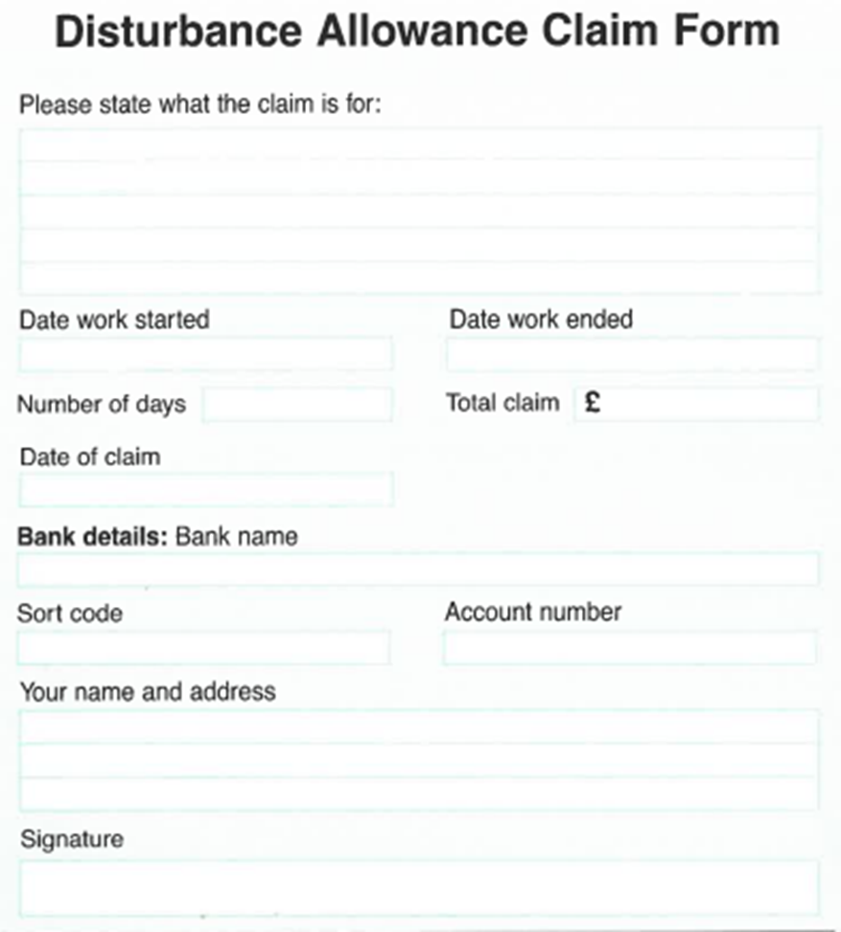

Appendix D – Gesture of goodwill payment matrix

 | Issue resolved within 24 hours of being made aware | Issue resolved within a week of being made aware | Issue resolved within 2 weeks of being made aware | Issue resolved within 4 weeks of being made aware | Issue resolved over 4 weeks of being made aware
Letter of apology
Low level inconvenience, without financial impact | Up to £50 | Up to £75 | Up to £75 | Up to £100 | Up to £100
Low level inconvenience, with financial impact | Up to £50 + costs | Up to £50 + costs | Up to £75 + costs | Up to £100 + costs | Up to £100 + costs
Medium level inconvenience, without financial impact | Up to £100 | Up to £150 | Up to £200 | Up to £250 | Up to £600
Medium level inconvenience, with financial impact | Up to £100 +costs | Up to £150 +costs | Up to £200 +costs | Up to £250 +costs | Up to £600 + costs
High level inconvenience, without financial impact | Up to £250 | Up to £300 | Up to £400 | Up to £500 | Up to £1000
High level inconvenience, with financial impact | Up to £250 + costs | £300 + costs | £400 + costs | £500 + costs | £1000 + costs
Personal injury of any kind | Pass to Insurance Team immediately - falls outside this policy
Missed appointment | £15 per appointment  Compensation may be ordered for repeated missed appointments and where loss of earnings on the tenant.

